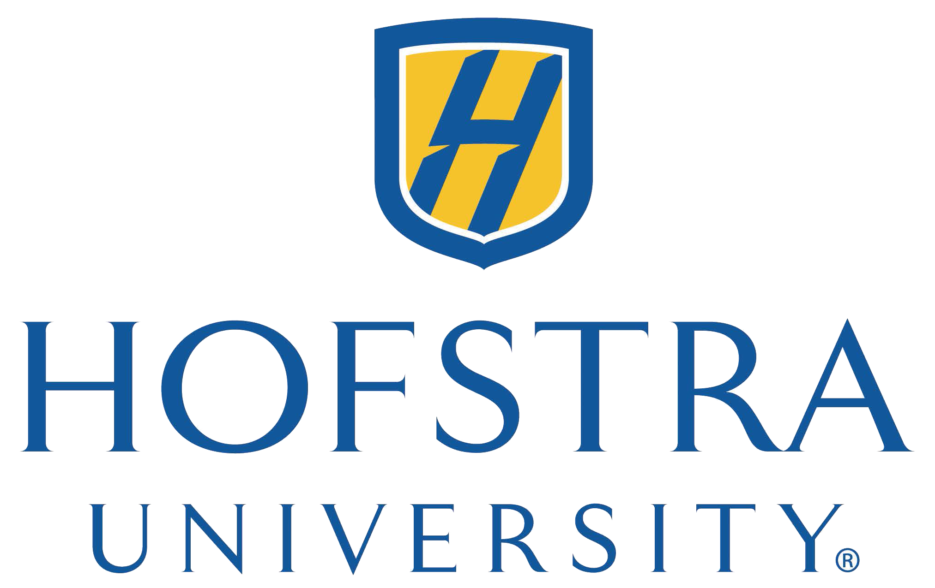

Hofstra University / GEOTeams
Summer Science Research
Fellowship Program

2023 Application Form
for Undergraduate Student Participants

Application Deadline: March 31, 2023

Mail or Scan and Email completed application to:

Hofstra University GEOTeams Summer Science Research Program
Department of Geology, Environment and Sustainability
114 Hofstra University, Hempstead, NY 11549-1140

Email: GEOTeams@hofstra.edu

Tel. (516) 463-5564
Fax (516) 463-5120

Undergraduate Engagement in GEOTeams
Summer Science Research Fellowship

Funding from the National Science Foundation (NSF) through the GEOPaths Program has made possible fellowship support for undergraduate students from Hofstra University to participate in mentored summer science research.

Four students from STEM departments at Hofstra, and four pre-service teachers, will be selected annually on the basis of this application and a recommendation letter from a professor. The project mandates that we include students from backgrounds that are underrepresented in the geosciences, which is why we are asking demographic information.

Students will be enrolled in the highly successful Hofstra University Summer Science Research Program (HUSSRP) and will work in four-person research teams in the field and on the HU campus from early July to mid-August (5 weeks). Each team will be led by a Hofstra University Geology, Environment, and Sustainability (GES) professor and will include two undergraduate students in addition to one high school student. One undergraduate student will be a pre-service teacher; one undergraduate student will be a STEM major. Each summer session will culminate in a public research poster presentation that will provide the students with the opportunity to showcase their work. At the conclusion of the program, each undergraduate STEM major student participant will receive a stipend of $2,250; each pre-service teacher will receive a stipend of $2,625.

Before being accepted into the program, all students selected for fellowship support will be invited to campus for a personal interview to meet with their faculty mentor and research team. Selected students will be matched with a participating faculty member and project based on the student’s research preference and faculty availability.

On Wednesday, July 5, 2023, from 1-2pm, all accepted students must attend a one hour orientation and laboratory safety session. The Summer 2023 program will run from July 5 to August 11, 2023. Students are expected to attend a weekly seminar / lunch on Wednesdays from 12:30-1:30pm, and a training session on each Monday, otherwise each student will decide on a mutually agreeable weekly work schedule with their respective research team. Students return to campus for a late afternoon poster session to present the results of their research in early fall (date to be determined).

Please provide the following information. Please type or print neatly in black or blue ink.

Student Information
________________________________________________________________________________
First Name: M.I. Last Name:
________________________________________________________________________________
Street Address:
________________________________________________________________________________
City: State Zip:
________________________________________________________________________________
Cell Phone: Email:
________________________________________________________________________________
Date of Birth: Anticipated Date of Hofstra Graduation:
________________________________________________________________________________

School Information
________________________________________________________________________________
Department at Hofstra: Are you a pre-service teacher?
_______________________________________________________________________________
Recommender (Professor/Mentor):
________________________________________________________________________________
Email: Phone:
________________________________________________________________________________

Courses you have taken:
What STEM or Education courses have you taken at Hofstra?

Course | Semester/Year | Professor | Grade received or  anticipated

Research Interests

Please indicate three areas in which you would prefer to do research. Specify your 1st, 2nd, and 3rd choice.

Paleoclimatology: using foraminifera or tree rings to decipher past climate.

Paleontology/sedimentology: Searching for dinosaurs and other Cretaceous vertebrate fossils on Long Island.

Climate/Meteorology: analyzing climate data from on-campus weather stations.

Volcanology: measuring growth of volcanoes.

Sustainability/Environmental Science: measuring Lead in Long Island soils.

I’m not sure and I’m open to any of these projects!

Please write a brief essay introducing yourself. You can answer these questions: Why are you interested in participating in a summer science research program? Have you participated in any other science programs? What do you hope to learn from your experience? What are your current professional goals for your college education and beyond?

Demographic Information

- What gender pronoun(s) do you use?
______________________________________________________________________________

- Are you of Hispanic, Latinx, or Spanish origin? (Please answer both this and the next question. Why we ask this question: we have a mandate to include students from backgrounds that are underrepresented in the geosciences. For this questionnaire, we borrowed questions from the U.S. 2020 Census at https://2020census.gov/en/about-questions.html, where Hispanic origins are not considered races. Hispanic origin can be viewed as one’s heritage, nationality, lineage, or country of birth. People who identify as Hispanic, Latinx, or Spanish may be any race.)
__Yes
__No
__Prefer not to say

- What is your race? (We borrowed these choices from the U.S. 2020 Census. We ask this question because we have a mandate to include students from backgrounds that are underrepresented in the geosciences.)
__White
__Black or Aftrican American
__American Indian or Alaska Native
__Chinese
__Filipino
__Asian Indian
__Vietnamese
__Korean
__Japanese
__other Asian
__Native Hawaiian
__Samoan
__Chamorro
__Other Pacific Islander
__Some other race: ____________________________________
__Prefer not to say

- Do you have a disability that will need accommodation in order for you to participate in the program? _________________________________________________________________

- Do you have a U.S. social security number? Yes or No (circle one)

Student Commitment

I, the undersigned, certify that the information provided by me on this form is true. I understand that if the student whose name appears on this form is admitted to Hofstra University’s GEOTeams Summer Science Research Program, I will agree to abide by all program rules and fulfill all requirements. The student understands that if accepted, they will be placed with a research mentor at the discretion of the Program Coordinators.

Printed Name of Student:

Signature of Student: Date:

