Title of Design Activity ________________________________________________________
Student Name ___________________________ Class and Period__________ Date: _________
List of students on design team:
_________________________________ ________________________________________
_________________________________ ________________________________________

Materials Needed: P.O. Box
___________________ ____________________ ____________________
___________________ ____________________ ____________________
___________________ ____________________ ____________________

What are Safety Issues that you must Consider?

1a. State the Design Challenge in Your Own Words:
____________________________________________________________________________________________________________________________________________________________

Clarify the Specifications (1b) and Constraints (1c):
____________________________________________________________________________________________________________________________________________________________

2) Research and Investigate – Complete any Pre-Design Tasks as Required
KSB/Task 1:
KSB/Task 2:
KSB/Task 3:
KSB/Task 4:
Etc.
3) Generate Alternative Designs (Describe at least two alternative designs)
Describe Alternative Design Solution 1

Describe Alternative Design Solution 2

4) Choose and Justify the Optimal Solution
What decisions did you reach that guided your choice of shelter design? Why did your group settle on this approach? What tradeoffs did you make in coming to this decision?

5) Display your Prototypes
Construct a model of your design. Include a photograph of the finished model.

6) Test and Evaluate Your Design
Explain how you designed a test for your solution, and what the results were.

7) Redesign the Solution
What did you learn through the design and/or testing of your model that would inform its redesign? What additional tradeoffs would you have to make?

8) Communicate Your Achievements
Describe the plan you will use to present your solution to your class. (Include a media-based presentation). Demonstrate how you tested the design. Explain what the key learnings were in this activity.

Student Presentation Evaluation Criteria

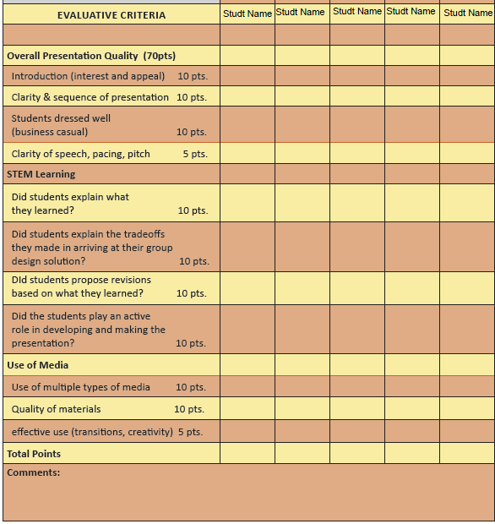

Informed Design Step | What Student Is Expected to Do | How Well Students did  (Level of Performance)
Informed Design Step | What Student Is Expected to Do | Level 1  Needs Improvement | Level 2  Acceptable | Level 3  Really Well Done
1a | Stating the Design Challenge | What student writes would not be adequate to clarify the challenge to a student in another class. | Challenge is restated exactly as provided by the instructor. | Additional detail is added that further explains the need for this work.
1b | Clarifying Criteria | Criteria are not identified or not described as performance specifications. | Criteria are explained in terms of what the design must accomplish. | Detailed performance specifications are provided.
1c | Clarifying Constraints | Constraints are not explained or not identified as limitations. | Student conveys understanding of constraints as external limitations imposed upon the design and provides at least one example. | Student identifies several design constraints by referring to those related to time, cost, materials, energy sources, human resources, information, tools and/or equipment,.
2 | Research and Investigate | Students did not complete all the pre-design tasks. | Students completed all the pre-design tasks. | Students completed all the pre-design tasks and ALSO did further research that informed their design solutions.
3 | Generate Alternative Solutions | Students generated only one design solution and did not consider alternatives. | Students discussed several alternative solutions but closed down on their choice with only limited consideration of other possible design options. | Students engaged in an interative group problem-solving activity to creatively generate several alternative design solutions.
4 | Choose and Justify the Optimal Solution | Students chose the solution originally generated without making a case for their choice that reflected consideration of alternatives. | Students explained why they chose the particular design solution and discussed tradeoffs that they weighed among alternatives. | In addition to discussing tradeoffs, students use quantitative measures to justify their choice.
 |  | Level 1  Needs Improvement | Level 2  Acceptable | Level 3  Really Well Done
5 | Develop a Prototype | Students did not construct a prototype. | Students used only representational models (e.g., drawings, sketches, written descriptions) but did not develop a working model. | Students developed a working model or a functional simulation to convey the essence of their design solution.
6 | Test and Evaluate the Design Solution | Students did not engage in formal testing or evaluation of their design solution. | Students tested the design against specific criteria and constraints. | Students developed a fair test and used it to analyze the strengths and limitations of their design relative to specified criteria and constraints.
7 | Redesign the Solution | Student reflections on where the design might be improved were not evident in any redesign. | Recommendations for design improvements were made based on student observations and discussion. | Recommendations for design improvements were made based on quantitative data accumulated through testing.
8 | Communicate your Achievements | See presentation rubric. | See presentation rubric. | See presentation rubric.

