

Candy Dispenser

Student Edition
2026



Grant Number – 2341962

Candy Dispenser Design Challenge

Challenge:

Calling all Candy Inventors!
Candy dispensers today are simple machines—press a button, and candy drops out. Your task is to design and build a better version.
Design and build a hands-free candy dispenser that reliably releases a small serving of candy when a user waves a hand near the sensor.
The dispenser must:
• release 8–12 pieces per activation
• use a distance sensor instead of a push button
• reset so it can be used again
• be sturdy and safe enough for repeated testing
• show thoughtful engineering and creative design
The goal is a dispenser that works consistently, not simply once.
The dispenser should also be safe to use and show some creative thinking in its design. When it is complete, it will be tested to see how well it works, how consistent it is, whether it operates hands-free, and how creative your team’s solution is.
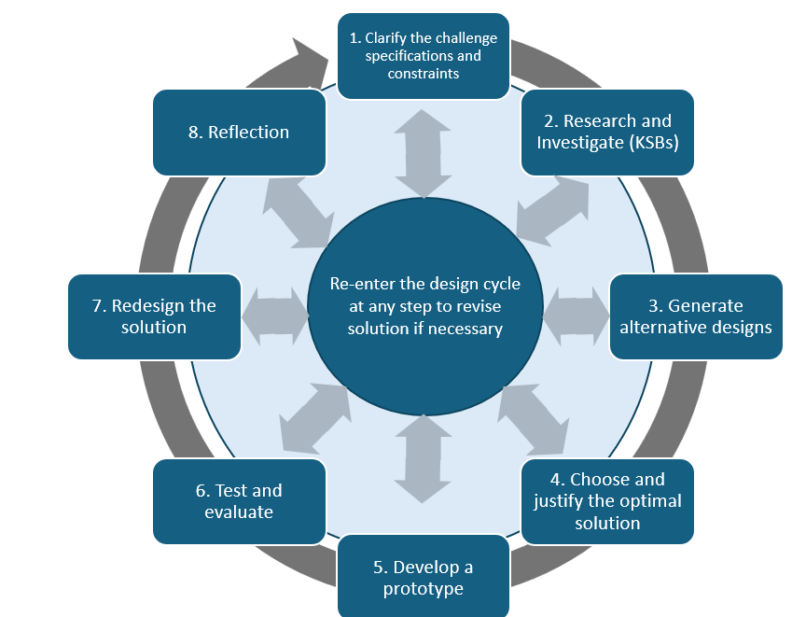

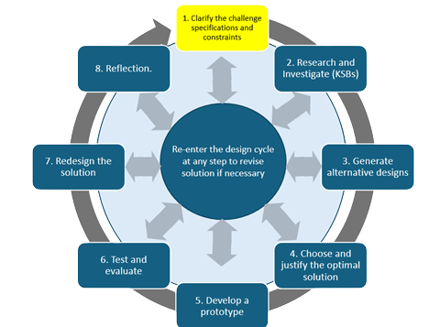

Specifications: (what does the design need to do)
Before you begin designing, identify the requirements that your dispenser must meet.

Example: The dispenser must release 8-12 pieces of candy during one activation.

Evidence: Create a short list of required specifications

Constraints: (things that limit your solution)

Identify the limits your team must work within, including available materials, Hummingbird components, class time, size, safety, and teacher requirements.

Evidence: Create a short list of project constraints.

Materials:
- Cardboard
- Shoe or Cereal box (optional)
- Hummingbird Kit
- Glue or hot glue gun
- Tape
- Scissors or box cutters
- Rules and pencils
- Brass Fasteners
- Misc. office supplies (paper clips, rubber bands, etc)
You do not need to use every material available. Select the materials that best support a safe and reliable dispensing mechanism.

Candy Dispenser Project – Assessment Rubric
Criteria | Beginning (1) | Developing (2) | Accomplished (3)
Clarify & Explore Understanding How Candy Machines Work | Explanation or sketch is incomplete. | Explanation identifies some parts of a dispenser and includes a usable sketch. | Explanation clearly describes storage, trigger, release control, possible failures, and includes an accurate labeled mechanism sketch.
Alternative Designs | One design or limited evidence is shown. | Two designs are shown with some comparison. | At least three meaningfully different labeled designs are shown; final design is justified using at least two criteria.
Programming Servo & Sensor Integration | Servo/sensor code is incomplete or unreliable. | Sensor triggers servo with some inconsistency; basic logic is explained. | Pseudocode and final code integrate sensor, servo, reset/delay behavior, and reliably support an 8–12 piece serving.
Prototype Build | Prototype is incomplete or unstable. | Prototype functions but needs improvement in stability, safety, or mechanism alignment. | Prototype is sturdy, safe, repeatable, and components are securely mounted; construction changes are documented.
Testing & Evaluation | Limited testing or no useful data. | Several trials are recorded and major results are described. | At least 5 trials are recorded in a data table; serving size, trigger behavior, jams, and patterns are analyzed against specifications.
Redesign & Improvement | A possible change is mentioned with little explanation. | A specific change is explained and connected to a problem. | A redesign is supported by test evidence; it is either retested or the predicted improvement is clearly explained.
Reflection | Reflection is general or incomplete. | Individual reflection explains specific learning and contribution. | Individual reflection uses project examples to explain learning, challenge, contribution, iteration, and a next improvement.

Knowledge and Skill Builders (KSBs)

KSB 1: What makes a Candy Machine Work?
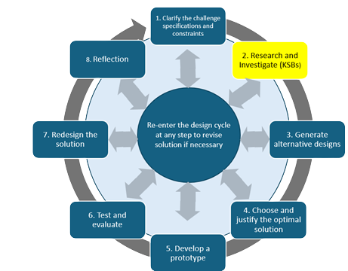
Before we start building, let’s think like engineers. Engineers start by studying how something works before creating something new or innovating. A candy machine might look simple on the outside, but inside it has several parts that work together. Those parts include storage for the candy, a mechanism to dispense the candy, and a trigger that starts the process.

For this activity, write a short “engineering” explanation of how you and your team think that a candy dispenser works. It should include:
- A description of how the machine releases the candy
- An explanation of the mechanism that controls how much candy is released (i.e. trap door, flap, wheel, etc)
- A discussion of possible problems a dispenser might encounter (jams, releasing too much or too little, breaking)
- A labeled sketch of what the inside of a dispenser mechanism might look like.

Evidence: Submit the analysis and required labeled sketch in a teacher-approved format.
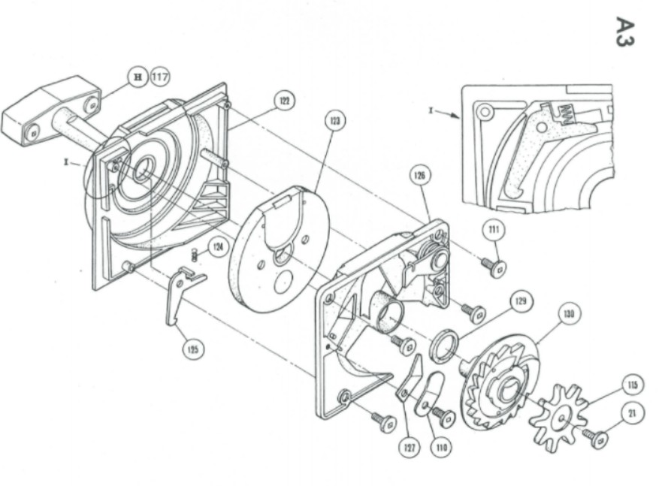
Fig 1. Exploded view of a coin mechanism for a candy machine

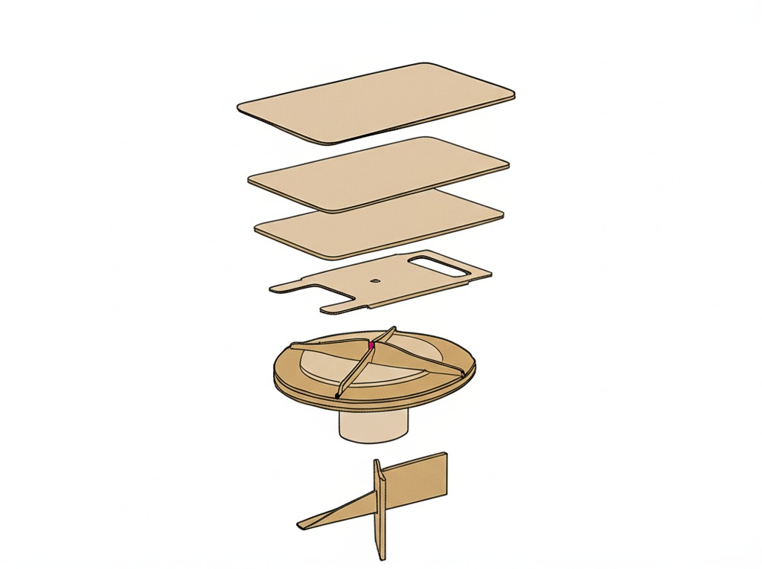
Fig. 2 Example view of a cardboard dispensing mechanism

KSB 2: How Does the Positional Servo Work?
A servo motor is different from a regular motor. Instead of spinning freely, it turns to a specific position or angle and then stops. That makes it perfect for jobs like dispensing a serving of candy.

In this step, you will connect a servo motor to your Hummingbird Kit and program it to move to a distinct position

Steps:
- Watch the video on the position servo https://learn.birdbraintechnologies.com/hummingbirdbit/snap/program/9-1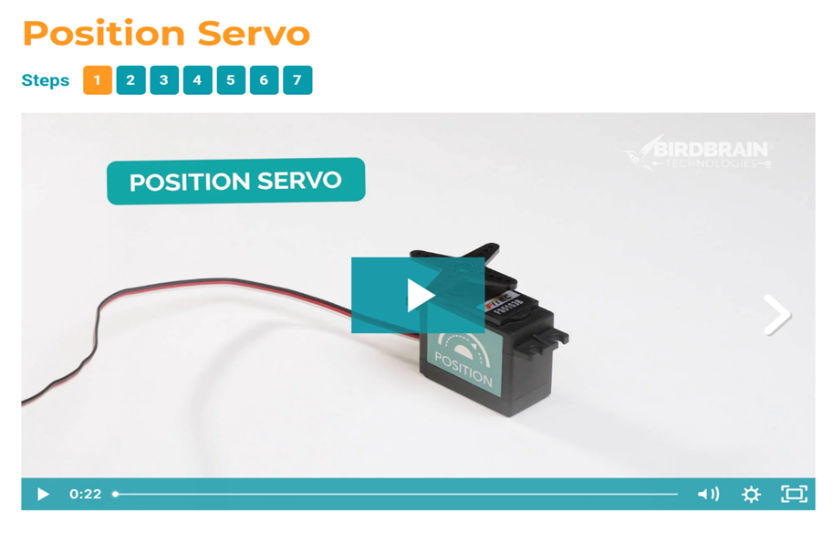
- Use Birdbrain Snap to program your servo to move to different set angles.
- Do not take this apart. You will need this as part of KSB 3.
Evidence:
• screenshot of the servo code
• the starting angle and at least two tested positions
• short note about which motion might be useful in a dispenser

KSB 3: Programming the Distance Sensor
A distance sensor can detect when something is nearby and how far away that object is. In your candy dispenser, it can act as a trigger. When someone waves their hand in front of the sensor, it should signal the servo motor to move. This makes your dispenser “hands free.”

Steps:
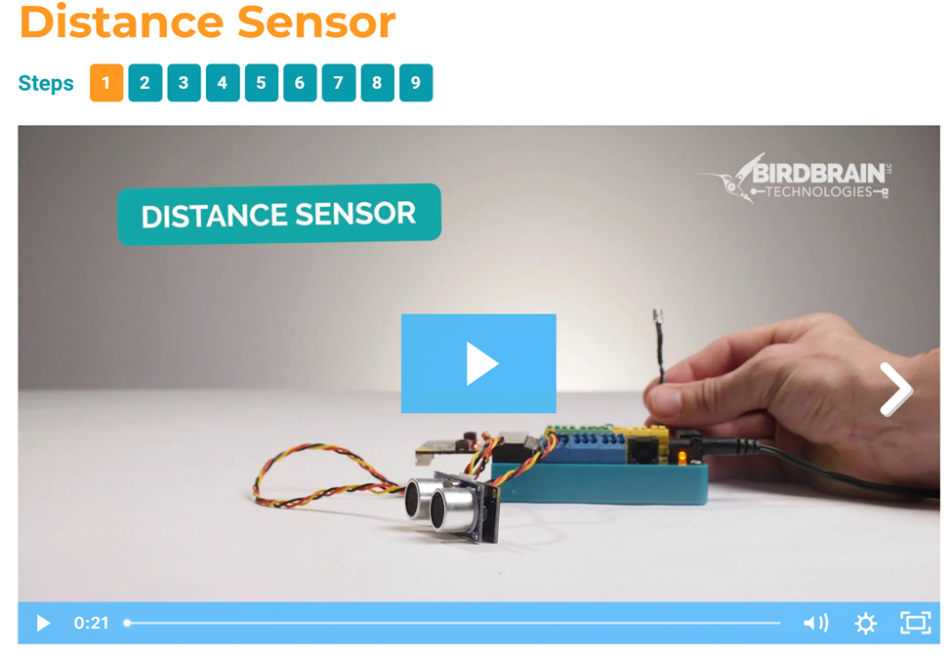
- Watch the video on the distance sensor https://learn.birdbraintechnologies.com/hummingbirdbit/snap/program/15-1
- Use Birdbrain Snap to write code so that when the sensor detects an object within a set range (like a hand), it triggers the servo motor.
- Experiment with different distance values until the sensor responds only when you want it to.
- Test the system several times to check that the sensor and servo work together.
Evidence:
• screenshot of sensor + servo code
• chosen trigger distance/range
• at least 3 test attempts
• short note explaining why your chosen distance works

Extension: Add a reset or short delay so one hand wave cannot accidentally trigger several servings.

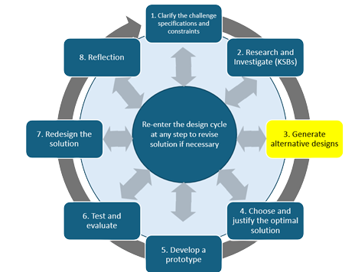
Alternative Candy Dispenser Designs
Now that you have thought about how candy machines dispense appropriate servings of candy and explored the servos and sensors, it is time to design your version. Engineers rarely build the first idea that they think of. Nope, they create and compare several possibilities before deciding which one to move forward with.

Create at least 3 meaningfully different dispenser designs. Each Sketch must show
- Approximate size of the machine
- Candy storage area
- Release mechanism
- Trigger mechanism
- Servo mounts
- Candy delivery area
Paste or draw your designs here.

Choose Your Optimal Candy Dispenser Design
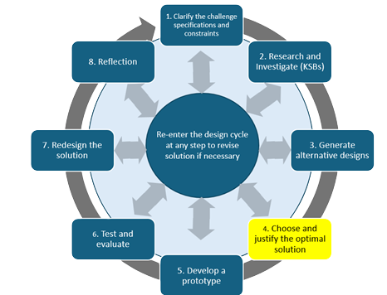
In engineering, the best design isn’t always the flashiest or the first idea that comes to mind. Good engineers compare their options, weigh the strengths and weaknesses, and then choose the design that best meets the challenge. This step is about making that decision as a team.

Decision Criteria:
When comparing your designs, consider these factors:
- Function – Will it reliably dispense the right amount of candy?
- Hands-Free Operation – Does it use the sensor effectively?
- Stability & Safety – Is it sturdy enough to be used multiple times and safe to handle?
- Creativity – Does it show innovation or unique features?
- Use of Materials – Can it be built with the supplies provided?

What to Do:
- Review the dispenser sketches with your team.
- Make a simple chart or list of the pros and cons of each design.
- Discuss which design is most likely to meet the challenge (dispenses the right amount, works hands-free, sturdy, safe, creative).
- As a group, decide on the design you will build.
- Write a short explanation (3–4 sentences) of why you chose this design.
Evidence:
• pros/cons comparison
• final labeled design sketch
• short explanation using at least two criteria to justify the final choice.

Build Your Optimal Candy Dispenser
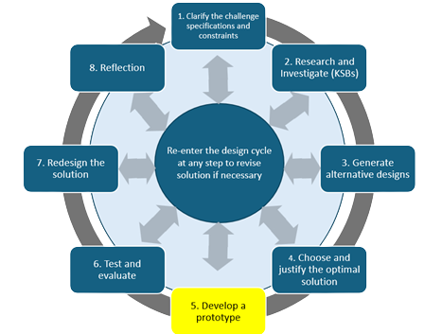
Now it’s time to turn your sketch into something real. Engineers call this the prototype stage — when an idea on paper becomes a working model you can test. Your team has chosen the design you believe will work best. Now you need to build it, piece by piece, using the materials provided.

What to Do:
- Start with the structure – Build the storage area for the candy. Make sure it’s strong enough to hold the weight.
- Add the release mechanism – Build the flap, wheel, or trapdoor that will let the candy out.
- Mount the servo and sensor – Secure your servo to move the release mechanism and place your sensor where it can detect a hand.
- Reinforce and refine – Use tape, glue, and fasteners to keep everything stable. Make adjustments if parts don’t line up.
Things to Remember:
- Follow your team’s sketch, but it’s okay to make changes if you find a better way.
- Build carefully — a weak or wobbly design won’t pass testing.
- Work together. Assign jobs so everyone is contributing.
Evidence:
• photo of the assembled dispenser before final programming
• brief note describing any major construction changes and why they were made

Optimal Candy Dispenser Code
A dispenser isn’t really a machine until it can run automatically. Up to now, you’ve built the structure, mounted your servo, and added your sensor. Now it’s time to connect them with code so the dispenser works hands-free.

What to Do:
- Plan the control logic with short pseudocode before writing the final program.
The logic should show:
• what counts as a hand trigger
• what the servo does when triggered
• how the servo returns/reset occurs
• how repeated accidental activation is prevented
- Open Birdbrain Snap! and connect your Hummingbird board.
- Write a program so that when the distance sensor detects a hand, the servo motor turns to release candy.
- Adjust the servo angles so that it drops only a small handful (4–8 pieces).
- Test the code several times and tweak it if it gives too much or too little candy.
Tips:
- Start simple: just turn the servo when the sensor is triggered.
- Add a short pause so the servo doesn’t keep spinning.
- If it’s not consistent, change the distance range or servo angle.
Evidence:
• pseudocode
• screenshot of final code
• short explanation of one code change made during testing.

Develop a Prototype
Combine the structure, sensor, servo, and final program into a complete working prototype.

Evidence:
• photo showing the completed dispenser
• photo showing the mechanism/component placement
• screenshot of final code
• brief note describing any major change made while integrating the system.

Test and Evaluate
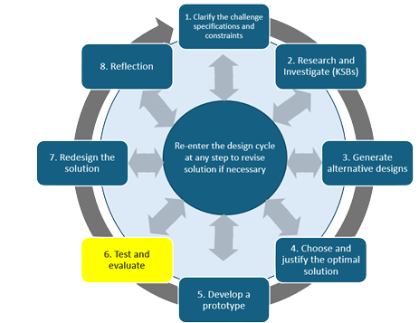
A good engineer never assumes a design works after the first try. Engineering testing is how you find out if your dispenser meets specifications. In this step, you will run multiple trials, collect data, and determine if your dispenser meets specifications.

What to Do:
- Run at least 5 complete dispensing trials.
- For each trial record:
• number of pieces dispensed
• whether the hand trigger worked
• whether a jam or delay occurred
• any change made before the next trial
- Then write a short testing summary explaining consistency, failure patterns, and whether the 8–12 piece specification was met.
Evidence: Submit the data table and testing summary.

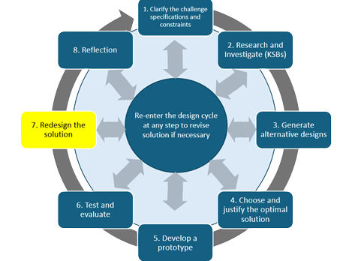
Redesign and Improve Your Dispenser
Engineers rarely get everything right the first time. Testing shows what works and what needs improvement. Now it’s time to take what you learned from your trials and make your dispenser better.

What to Do:
Use your test evidence to identify at least one meaningful improvement.
If time and materials allow, make the change and retest. If implementation is not possible, explain what you would change and what result you predict.
Evidence:
• redesign idea tied to test evidence
• explanation of the expected improvement
• if implemented, results from at least 2 retests.

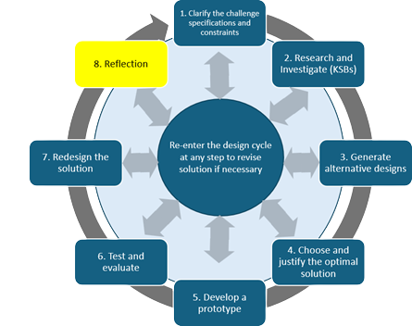
Reflection
The last step in engineering is to share what you created and reflect on what you learned. This is your chance to explain your design, show how it works, and think about what you would do differently next time.

What to Do:

- Answer the reflection questions below:
  - What part of this project was most successful?
  - What was the biggest challenge your team faced?
  - How did your team solve problems together?
  - What new skills did you learn (design, coding, building, teamwork)?
  - If you had more time, what would you improve or add?

Candy Dispenser Project – Assessment Rubric
Criteria | Exemplary (4) | Proficient (3) | Developing (2) | Beginning (1)
Clarify & Explore Understanding How Candy Machines Work | Thorough write-up with detailed explanation of triggers, release mechanisms, and possible failures; accurate sketch with labels. | Adequate explanation of how a dispenser works; sketch mostly accurate with labels. | Partial explanation; limited or vague understanding of mechanisms; incomplete sketch. | Minimal or no explanation; no sketch or sketch unrelated to task.
Alternative Designs | Two creative, well-labeled sketches; strong pros/cons analysis using criteria; clear, thoughtful justification for final choice. | Two labeled sketches; pros/cons analysis includes most criteria; justification is reasonable. | Only one sketch or incomplete labeling; weak comparison; limited justification. | No usable sketches; no comparison or justification provided.
Programming Servo & Sensor Integration | Code is correct, efficient, and integrates servo + sensor smoothly; dispenser operates reliably. | Code integrates servo and sensor with minor glitches; mostly reliable. | Code partially works; inconsistent function between servo and sensor. | Code does not work or was not attempted.
Prototype Build | Prototype is sturdy, safe, and matches design sketch; servo and sensor are securely mounted; materials used effectively. | Prototype functions with minor stability/safety issues; mostly matches design sketch. | Prototype partially works but is unstable or incomplete; poor material use. | Prototype does not function or was not built as planned.
Testing & Evaluation | At least 5 trials recorded in a clear data table; patterns analyzed; strong written evaluation of performance. | Multiple trials recorded with some data analysis; evaluation addresses accuracy/consistency. | Limited testing (fewer than 5 trials); weak or incomplete evaluation. | Little or no testing or data analysis.
Redesign & Improvement | Meaningful improvements documented; explanation shows clear connection to test data; retesting proves improvement. | Some improvements made and documented; partial connection to test data. | Few improvements attempted; weak or missing documentation. | No redesign attempted.
Reflection | reflection answers show deep learning and teamwork insight. | reflection answers are complete. | reflection answers incomplete. | no reflection completed.

Resources:
How does a Gumball Machine work?https://youtu.be/Q3ZeUNDg4fQ?si=3Ac87xA0gyjx8wGw
DIY Amazing Spiral Gumball Machine from Cardboard at Homehttps://youtu.be/RWXlIx8ilJ4?si=R3JHvmM7qEkeTRU4
DIY How to make Candy Dispenser from Paper Cup Craft｜Paper Craft Ideas with M&M'shttps://youtu.be/I0-M0uhRNqY?si=vu-yFrMOXBXDjTea

