

Light and Sound
Student Edition
2026



Grant Number – 2341962

Conducting a Light and Sound Show

Challenge

You and your team will design and build an interactive Conductor’s Magical Box that creates a light and sound show in response to motion.
You will “conduct” the show by moving your hand into and out of the open end of the box. A distance sensor will detect how far your hand is from the sensor. Your code will use that distance to control the lights and music.
The goal is to create a system that responds clearly and consistently as the conductor moves their hand through the box.
- Include blinking lights.
- Play different musical tunes at different hand distances.
- Allow each tune to play for at least 10 seconds.

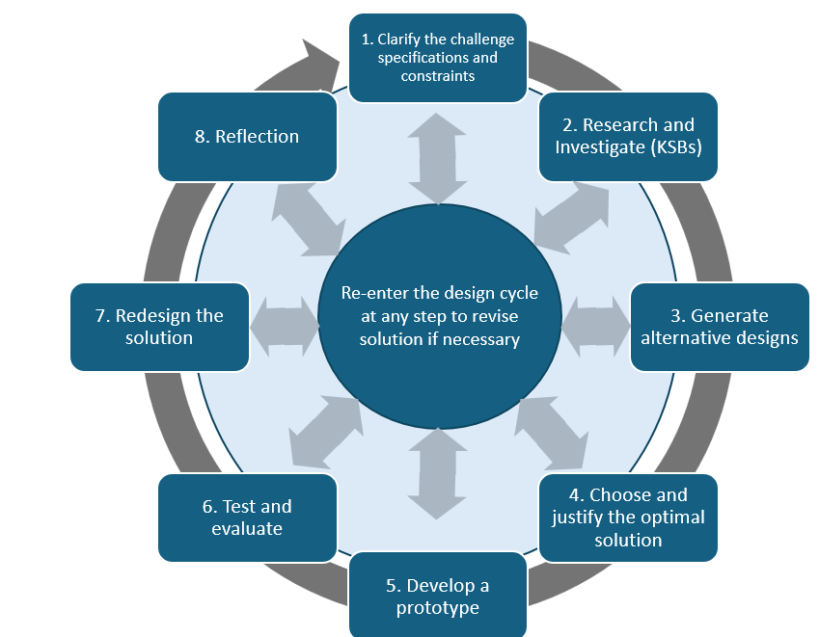

Specifications –What your design must do. Before you begin designing, identify exactly what you solution must do.

(Example: They system must play different music when the conductor’s hand moves into different zones.)

Create a short list of the required specifications for your design.

Constraints — Things that limit your solution. Identify the limits your team will need to work within.
Evidence: Create a short list of the constraints your team will need to consider.

Materials
Cardboard
Glue gun
Tape
Ruler
Hummingbird LED lights
Hummingbird distance sensor
Other approved classroom materials

You do not need to use every material available. Choose only the materials that help your design work effectively.

Light and Sound Assessment Rubric
Criteria | 1 – Beginning | 2 – Developing | 3 – Accomplished
Alternative Designs | One design idea described. No explanation of how it meets the project goals or constraints. | Two design ideas described. Provides a reason why one design was chosen based on ease of implementation or expected performance. | Three or more design ideas clearly described. Preferred design selected and justified using at least two criteria (e.g., sensor effectiveness, light/sound coordination, user control).
Music Design | One tune plays regardless of hand distance. Tune is less than 10 seconds long. | Two different tunes are triggered at different distance zones (e.g., 0–20 cm and 21–40 cm). Each plays at least 10 seconds. | Three or more distinct musical segments are triggered at clearly marked distance zones (e.g., 10–30 cm, 31–50 cm, 51–70 cm). Each segment plays for at least 10 seconds. Includes a silent zone (e.g., <10 cm or >70 cm) as part of the design.
Light Design | LEDs remain solid (on or off) during the show. No blinking or color changes. | LEDs blink continuously during the show. Blinking is not tied to user motion or music. | LEDs are coded to blink in distinct patterns and/or colors for each distance-triggered musical segment. Patterns visibly change when the hand moves between marked distance zones. Lights are synchronized with hand movement and music transitions.
Final Design and Code | Includes a photo of the prototype and an unannotated screenshot of the final code. | Includes a photo and code with 1–2 sentence explanation of what the code does. | Includes a photo of the final product, annotated code (e.g., comments in Snap), and a 3–5 sentence explanation of how the code triggers lights and music based on distance. The physical box includes clearly labeled distance zones in cm. Code uses if-else logic to vary output based on distance ranges.
Testing and Evaluation | No structured testing. No explanation of what worked or didn’t. | Conducted 1–2 test trials to check whether music/light respond to hand motion. Brief explanation of one success or failure. | Conducted at least three test trials. Documents exact outcomes for each distance zone (e.g., 'At 25 cm, tune 2 played and blue lights blinked.'). Explains fixes made after testing.
Redesign Thinking | No redesign is attempted or discussed. | Describes one change that might improve appearance or function (e.g., repositioning sensor). No changes implemented. | Implements at least one redesign (e.g., code update, repositioned LEDs). Explains what was changed and how it improved performance.
Reflection on Learning | Provides one vague or general statement (e.g., 'I learned how to code.'). | Names two specific things learned (e.g., 'how to use the distance sensor' and 'how to blink LEDs'). | Explains at least two learnings with specific examples from the project (e.g., 'I learned how to use “if-else” in Snap to switch between songs based on distance.').

Knowledge and Skill Builders (KSBs)

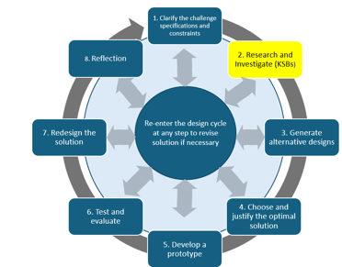
KSB 1—Preliminary Design. Before you build the Conductor’s Magical Box, create a plan for how it will respond when you move your hand.
You will be conducting the ‘show’ by moving your hand in the Conductor’s box. A distance sensor will detect how far away your hand is from it and this information can be used by you to turn on lights and create and change sounds.

The distance sensor operates most effectively between 10—80 cm, but you may want to make the box about 60-80 cm (about two feet) so it fits on a desk or table.

You may mark distance zones inside the box. Decide what the music/sound and lights should do in each zone. Remember that sound may respond slightly slower than the LEDs, so your design may need to account for that timing difference.
Evidence: Create a preliminary design sketch and a short explanation.
- Show the sensor location.
- Show the direction the conductor’s hand will move.
- Show planned distance zones.
- Show approximate overall dimensions using the measurement system your teacher requires.
- Show approximate placement of lights or other major components.
- Explain what should happen in each zone and the sequence the computer should follow.

Below is an example of a Conductor’s Box; notice the small opening at the end for the distance sensor to be inserted. The tape indicates a zone where no music is played.

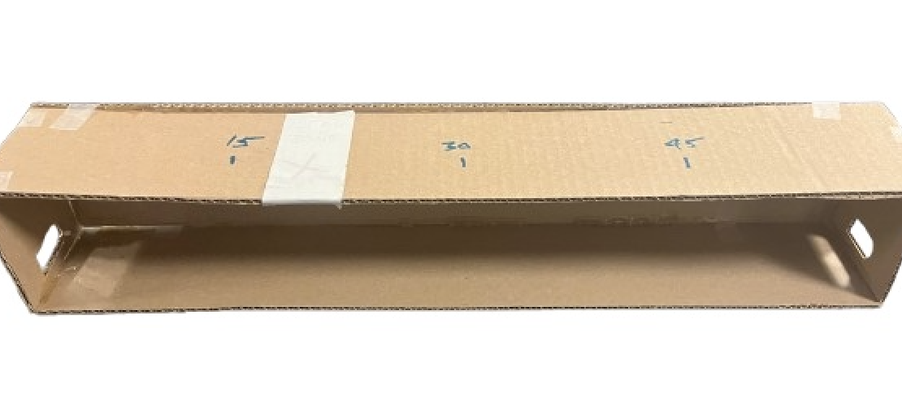

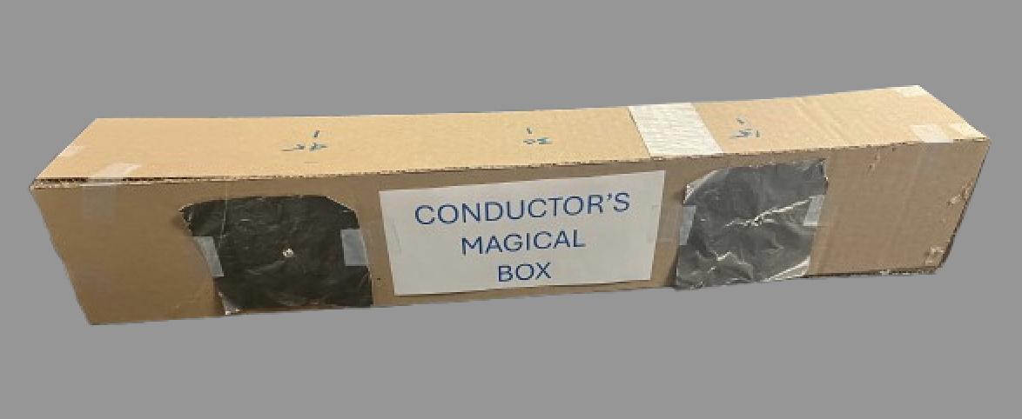

This is the front of Conductor’s Magical Box. The LEDs are positioned in the center of the aluminum foil, which is used to spread out the light from the LED so it has a greater impact.

Now think about what you would like to have happen when you move your hand from the starting position. Do you want a defined starting position? Should a song play, or should individual notes sound? What kind of lighting effects would you like—specific colors, blinking patterns, or color changes synchronized with the music? Keep in mind there is a lag time from when you move your hand until the sound starts, the LEDs are quicker to respond.

Evidence
Explain the sequence of actions the computer must make, step-by-step, as your hand moves through the box.

KSB2—How the Distance Sensor Works

Use the BirdBrain Technologies resource to learn how the Hummingbird distance sensor works and how to read its values in Snap.

Test the sensor: Build and run a simple program that shows the sensor values changing as you move your hand closer to and farther from the sensor.

https://learn.birdbraintechnologies.com/hummingbirdbit/snap/program/15-1

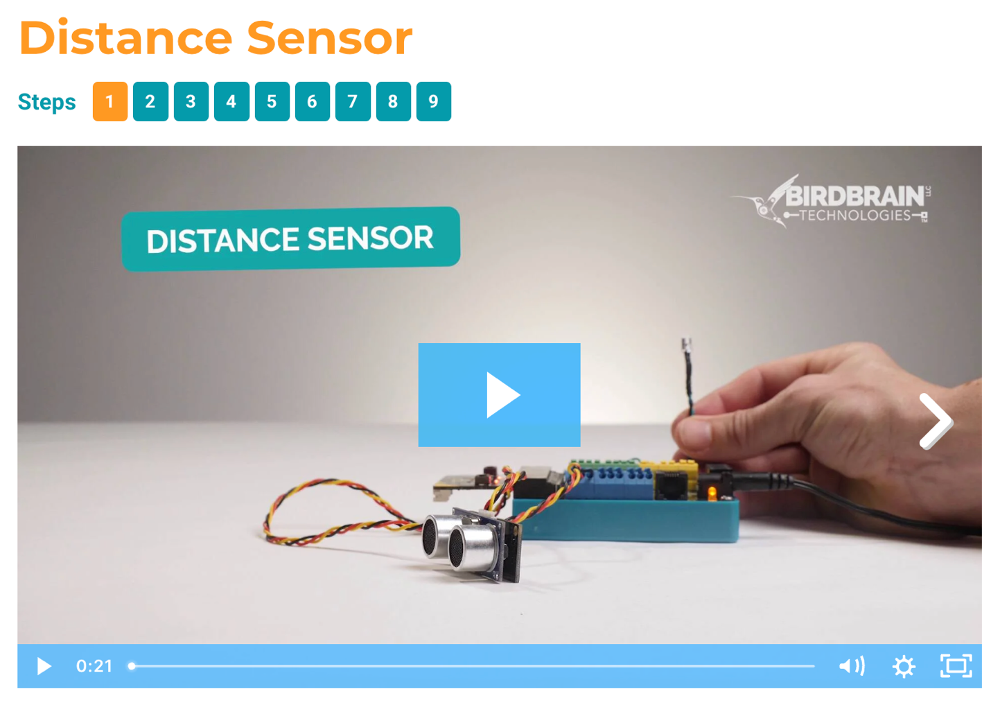
Evidence: Submit a screenshot of the code, 3 sample distance readings from different hand positions, and one short statement about what you noticed about how the sensor responds.

KSB3—How single color LED Works
Use the BirdBrain Technologies resource to learn how to connect and control a single-color LED with the Hummingbird.
Start by writing and testing code that turns one LED on and off. Then connect a second LED and write code that allows you to control both LEDs.

https://learn.birdbraintechnologies.com/hummingbirdbit/snap/program/6-1

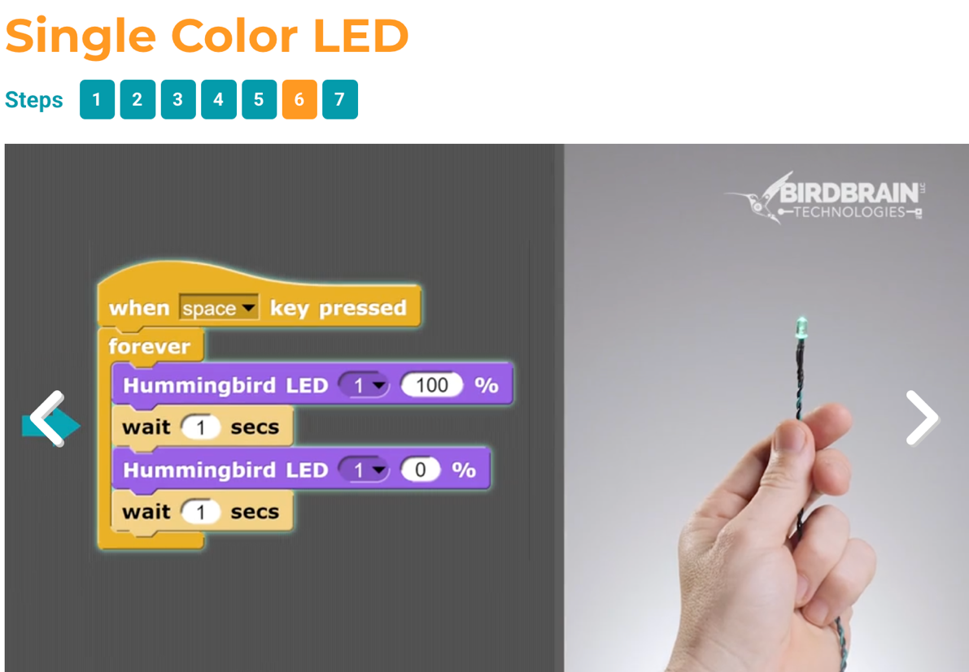

The code above is for one LED. Now write code to make two LEDs blink.

Evidence: Submit a screenshot of your code controlling two LEDs and a short statement describing what you learned about controlling them.

Extension Challenge: Make the two LEDs blink in a pattern. Try changing the timing or sequence—for example, alternate them, blink them together, or create your own pattern.

Alternative Light and Sound System Designs
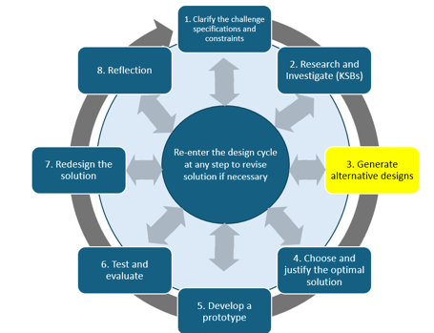
Before choosing your final design, create at least 3 meaningfully different design ideas for your Conductor’s Magical Box.
Evidence: Submit 3 design sketches with short explanations. At this stage, you are exploring possibilities. You do not need to decide which design is best yet.
- Include approximate size and major component placement.
- Show sensor location and distance zones.
- Describe how the lights will respond.
- Describe how the sound or music will respond.

Optimal Light and Sound System—Part 1—The Structure
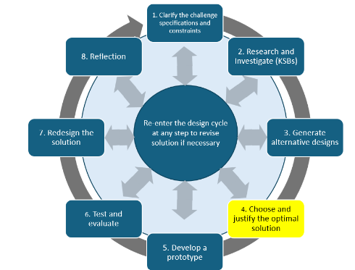
Review your 3 alternative designs. You may choose the design you think will work best, or combine the strongest features from multiple ideas to create a new best design.
Evidence: Submit a final sketch of your best design with approximate dimensions, sensor/light/major component placement, distance zones, and a short explanation of why you selected or created this design.
- Use at least two design reasons, such as reliability, ease of use, sensor placement, light/sound coordination, or user experience.

Optimal Light and Sound System—Part 2—Light and Sound Code
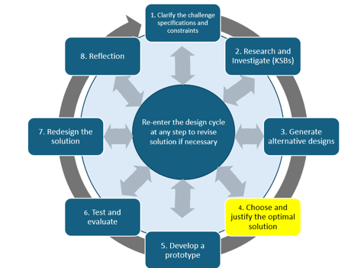
Before building the final program, use pseudocode to describe the logic of your program in plain language.
Pseudocode is a simple, fake code used to plan computer programs using plain English
Your pseudocode should show what happens in each distance zone, which tune/sound should play, what the lights should do, what happens in any silent zone, and how the program moves from one condition to the next.
Build and test the code using your pseudocode as a plan. Expect to revise the code as you test it.
Evidence: Submit your pseudocode, a screenshot of the final code, and a short explanation of one change you made while testing.
.

Develop Your Prototype
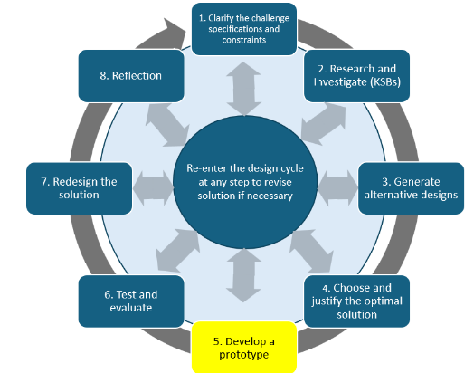
Build the Conductor’s Magical Box using your final design as the starting plan. As you build, you may change the physical design if testing shows that something works better another way.
You may adjust dimensions, sensor placement, LED placement, materials, or other physical features.
Optional: Mark distance zones on the box if that helps your team test or conduct the show more accurately.
Evidence: Submit one photo showing the audience view, one photo showing the conductor view, one photo or screenshot of the final code, and a brief note describing any major changes made during construction and why.

Test and Evaluate
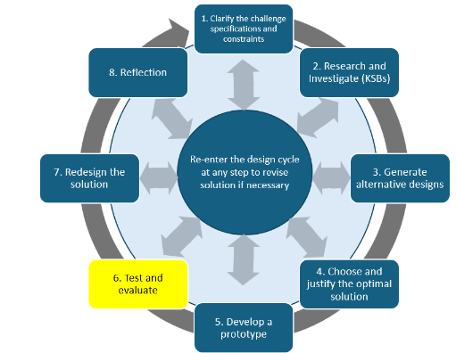
Engineers test designs to find out what actually works. Test your Conductor’s Magical Box at least 3 complete times. During each trial, move your hand through every planned distance zone and compare what you expected with what actually happened.
If you make a meaningful change after testing, run another trial to see whether the change improved performance.
Evidence: Submit the completed test table and a short testing summary explaining whether the design met the challenge requirements, what worked consistently, what did not work as expected, and what changes you made

Distance Zone | Expected Result | Actual Result | Change Made
Zone 1
Zone 2
Zone 3
Additional Zone

Redesign Ideas

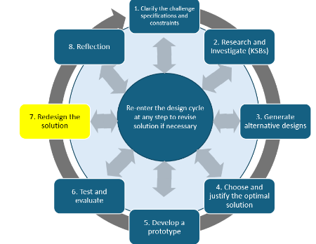
Engineers improve designs based on what they learn from testing. Review your test results and identify at least one change that could make your Conductor’s Magical Box work better.
Evidence: Submit one redesign idea and a short explanation of why you think it would improve the system.
If time and materials allow, make the change and test it again. If you do not make the change, explain what you would change and what you expect to improve. If you do make the change, briefly describe what happened after you tested it

Reflection
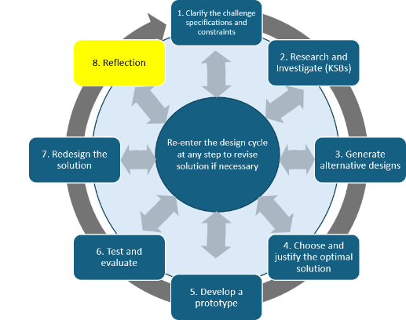
Even if you completed the challenge as a team, each team member will complete their own reflection. Use specific examples from the project.
Evidence: Submit your own reflection as a short written response, audio response, video reflection, or another format approved by your teacher.
- What is one important thing you learned about the distance sensor, LEDs, or code?
- What part of the project was most challenging, and how did you respond to it?
- What did you contribute to your team’s final design?
- What changed from your original idea to the final prototype?
- If you had more time, what would you improve next?

Light and Sound Assessment Rubric
Criteria | 1 – Beginning | 2 – Developing | 3 – Accomplished
Alternative Designs | One design idea is shown. The sketch or explanation is incomplete. | Two design ideas are shown with sketches and brief explanations. | At least three meaningfully different design ideas are shown. Each includes a sketch and enough detail to explain how the system would work.
Music Design | One tune plays, or the music does not clearly change based on hand distance. | Two different tunes are triggered by different distance zones. Each tune plays for at least 10 seconds. | Three or more different musical segments are triggered by clearly planned distance zones. Each plays for at least 10 seconds. The design may also include a silent zone.
Light Design | LEDs turn on or off but do not respond consistently to the conductor’s movement. | LEDs respond to the system and may blink or change as the hand moves. | LEDs use planned blinking patterns or other changes that clearly respond to different distance zones and coordinate with the sound design.
Final Design and Code | A prototype and code are created, but the design or program does not fully respond to hand distance. | The prototype and code respond to hand distance in more than one zone. Pseudocode and final code show the basic logic of the system. | The prototype reliably responds to multiple distance zones. Pseudocode clearly plans the logic, and the final code controls both lights and music as intended. Final evidence includes the required prototype views and code.
Testing and Evaluation | Limited testing is completed, or results are not recorded clearly. | At least two complete trials are conducted. Results show what happened in the different distance zones and identify at least one problem or success. | At least three complete trials are conducted, with every distance zone tested during each trial. Expected and actual results are recorded, and changes made during testing are explained.
Redesign Thinking | A possible improvement is identified with little explanation. | A specific redesign is identified and explained, including why it could improve the system. | A specific redesign is supported by evidence from testing. The team either tests the redesign or clearly predicts how the change would improve performance.
Reflection on Learning | The reflection gives general statements with few project examples. | The reflection explains specific learning and describes the student’s contribution to the project. | The individual reflection uses specific examples to explain learning, challenges, contributions, changes from the original design, and possible next improvements.

