

Designing a Crosswalk Light System

Student Edition
2026



Grant Number – 2341962

Designing a Crosswalk Light System

Challenge

Crossing the street without a signal that indicates it is safe can be dangerous, and our goal is to help people to cross safely.
In this challenge, the street is 30 feet wide with two lanes of traffic. Cars are traveling at 35 mph, or about 51.3 feet per second. When the crosswalk system is activated, your design must allow enough time for drivers to react and slow to a stop before the pedestrian receives the Walk signal.

Your system must include:
• a steady red Don’t Walk signal when crossing is not safe
• a steady green Walk signal when crossing is safe
• a blinking red Don’t Walk signal for 3 seconds near the end of the crossing sequence
• a sensor that activates the crossing sequence

Your goal is to create a clear, reliable sequence that uses timing, sensors, lights, and code to model a safer crossing system.
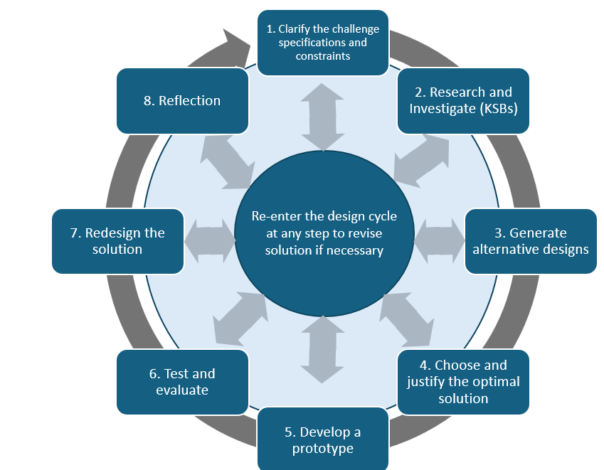

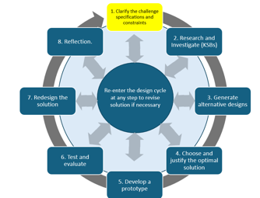
Specifications (what does the design have to do)

Think about what the crosswalk signal must do. Before you begin designing, identify the specifications your solution must meet.

Example specification: The system must show a Walk signal only after the programmed safety delay has finished.

Evidence: Create a short list of the required specifications for your design.

Constraints (things that limit your solution)

Think about what limits your solution possibilities. Identify the limits you will need to work within, such as available materials, time, component capabilities, size, and the required street/timing information.

Evidence: Create a short list of the constraints your team will need to consider.

Materials

Cardboard or other construction materials
Tape
Glue
Measuring tools
Hummingbird LED lights
Hummingbird light sensor
Glue gun
Other classroom materials approved by your teacher

You do not need to use every material available. Choose materials that support your design. The Hummingbird light sensor and light outputs remain core components of the challenge.

Assessment Rubric: Design and Engineering

Criteria | 1 | 2 | 3
Alternative Designs | Describes one design idea. No rationale or consideration of alternatives provided. | Describes two design options and explains the choice using one reason (e.g., easier to build or test). | Describes three or more design options and explains final choice using multiple factors (e.g., efficiency, accuracy, feasibility).
Crossing Time Calculations | Provides incomplete or unclear explanation of crossing time. Lacks calculation steps. | Accurately calculates vehicle slow-down and pedestrian crossing time. Explanation includes steps. | Accurately calculates vehicle and pedestrian times. Answers all related questions with complete, step-by-step explanations and units.
Sensor Operation Code | Uploaded code for LED only. No explanation or integration with sensor. | Uploaded code integrates LED and light sensors. No explanation of logic. | Uploaded code uses LED and light sensors with clear explanation or comments showing how sensor data controls LED behavior.
Final Design and Documentation | Includes only a photo and basic code. No explanation. | Includes photo, code, and a short explanation of how the system works. | Includes annotated code, labeled photo, and detailed explanation of function and changes made during development.
Testing and Evaluation | Little or no testing. No discussion of whether design met goals. | Performs basic testing and explains one result (e.g., LED turned on when it should). | Conducts structured testing for multiple cases. Explains whether design met goals and what was revised or could be improved.
Reflection on Learning | Mentions one general takeaway (e.g., 'I learned about timing.'). | Identifies two things learned with examples (e.g., using sensors or debugging code). | Provides a thoughtful reflection on at least two learnings, including challenges faced and strategies used to solve them.

Knowledge and Skill Builders (KSBs)

KSB 1: Preliminary Design
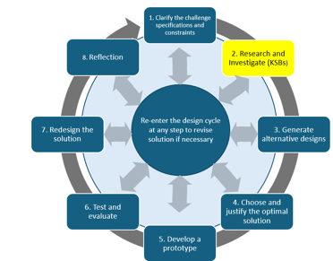
Think about crossing the street where there is a crosswalk. There are different colored lights that indicate “Walk” and “Don’t Walk.” Typically, the “Don’t Walk” light is on until you push the button. When you do so, the light does not immediately turn to “Walk” because there needs to be time for cars to slow down and come to a complete stop.

Study the crosswalk examples. Notice how real systems use words, symbols, color, or a combination so that pedestrians can quickly understand the signal. Your design may use words, symbols, or both.

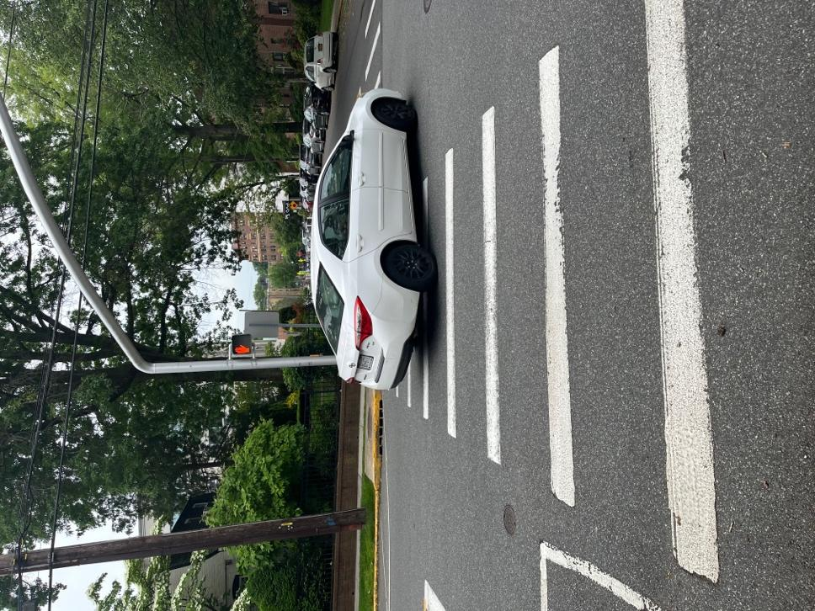
Figure 1. The “Don’t Walk” signal is on, showing a red hand, while a car is turning, indicating that cars are allowed to go through the intersection.

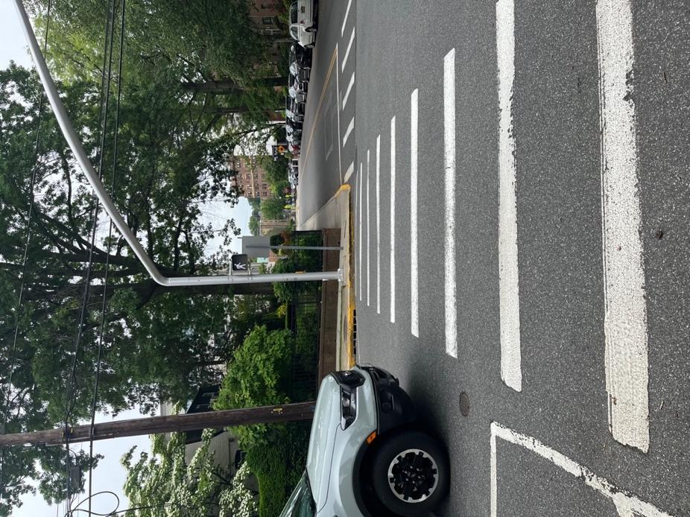
Figure 2. The “Walk” signal is on, the car is stopped, and people can safely cross the street.

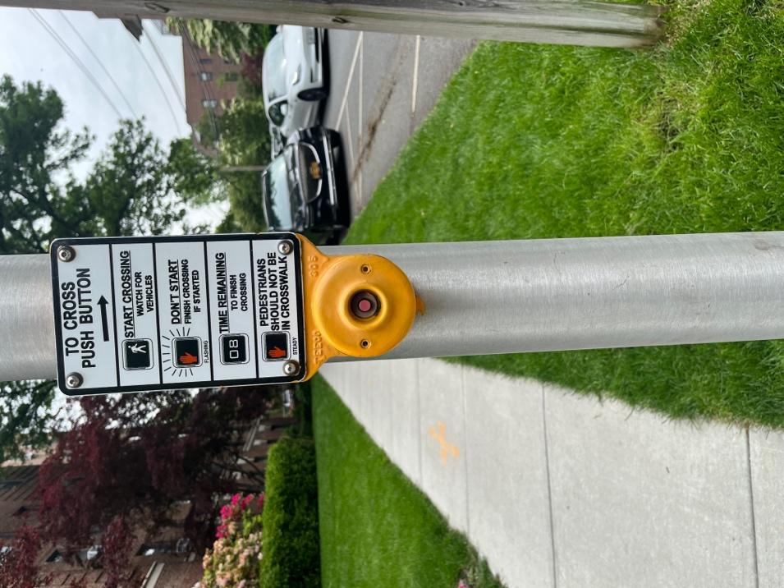
Figure 3. Crosswalk push button with information about the signal.

Your preliminary design should include a way to show Walk and Don’t Walk and a sensor that will act as the crossing trigger. Later KSBs will help you calculate timing and program the system, so this first design can change as you learn more.

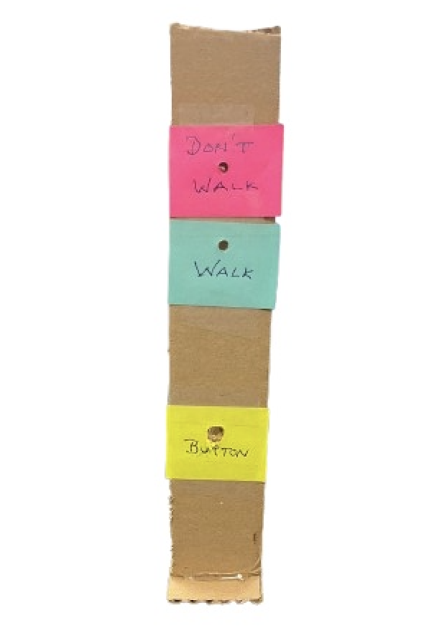
A basic crosswalk system with a button to push and “Walk” and “Don’t Walk” light indicators.

Evidence — Preliminary Design Sketch

Create a required sketch that shows:
• the Walk and Don’t Walk indicators
• the location of the light sensor/activation area
• approximate dimensions using the measurement system your teacher requires
• major component placement
• words, symbols, or both for communicating with the pedestrian

Add a short explanation of what you want the system to do from the moment it is activated until it returns to Don’t Walk.

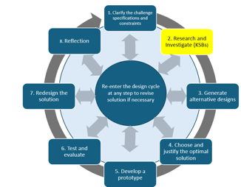
KSB 2 Crossing Time
Traffic designers have standards that they must work from in order to create a safe crosswalk.

Use the information below to plan the timing of your model crosswalk system.

Given information:
• pedestrian walking speed: 4 ft/s
• street width: 30 ft
• vehicle speed: 51.3 ft/s (35 mph)
• driver reaction time: 0.75 s
• vehicle deceleration after braking begins: 15 ft/s²
• blinking Don’t Walk phase: 3 s

Calculate and show your work:
- Braking time: How long would it take a vehicle traveling 51.3 ft/s to slow to 0 ft/s at 15 ft/s²?
- Safety delay: Add the 0.75 s reaction time to the braking time. How long should your model wait before showing Walk?
- Crossing time: How long does it take to cross 30 ft at 4 ft/s?
- Decide when the 3-second blinking Don’t Walk phase should begin and end.
- Decide when the signal should return to steady red Don’t Walk.

Consider whether your Walk time should be longer for people who may cross more slowly. Explain any additional time your team chooses to add.

Evidence: Submit your calculations with units, your final timing sequence, and a short explanation of the choices your team made.

KSB 3 How Sensors Operate
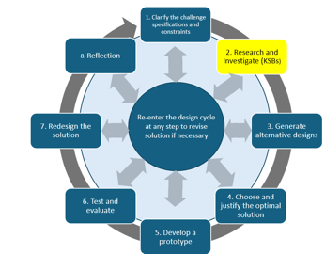
Use the BirdBrain Technologies resources to learn how the Hummingbird light sensor and LEDs work in Snap.

In this project, the light sensor replaces the traditional push button. Covering the sensor with a finger creates a low light reading. A reading below 10 can be used as the trigger for the crosswalk sequence.

Light sensor resource:
https://learn.birdbraintechnologies.com/hummingbirdbit/snap/program/13-1

LED resource:
https://learn.birdbraintechnologies.com/hummingbirdbit/snap/program/6-1

Test the System:
Write and run code so that darkening the light sensor turns on an LED. Test the sensor at several light levels so you can see how the value changes.

Evidence:
- screenshot of the code that uses the light sensor to control an LED
- at least 3 sample sensor readings from different light conditions
- one short statement explaining what happens when the sensor reading drops below the trigger value

KSB 4 Thinking Like a Computer

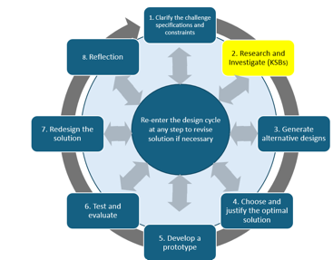
Computers are controlled by code; in this case, the computer program you create will control the lights to help a person safely cross the street.

Think about what you want to happen step by step. This is how the computer reads the directions you give it through the code you write.

Before you build the complete program, plan the logic using pseudocode — step-by-step directions written in plain language.

Go back to the challenge statement and your timing calculations. Your pseudocode should show what the system does:
  - while the sensor has not been activated
  - when the light sensor is covered and triggers the system
  - during the safety delay
  - during the Walk phase
  - during the 3-second blinking Don’t Walk phase
  - when the system returns to steady Don’t Walk and is ready to begin again

Evidence: Submit your pseudocode sequence. It should be clear enough that another student could use it as a plan for writing the program.

Alternative Crosswalk Light System Designs

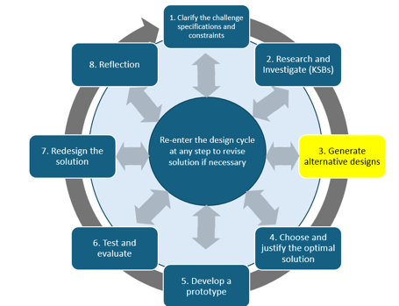
What do you want your crosswalk light system to look like? Where are you going to place the “Walk” and “Don’t Walk” indicators?

Before choosing your final design, create at least 3 meaningfully different crosswalk system ideas.

Each design should include:
  - a sketch of the structure
  - approximate size and major component placement
  - location of the light sensor/activation area
  - placement of the Walk and Don’t Walk indicators
  - words, symbols, or both
  - a brief explanation of how a pedestrian would use and understand the design

Your construction materials may vary based on what your teacher makes available.
Evidence: Submit 3 design sketches with short explanations. At this stage, explore possibilities — you do not need to choose the best design yet.

Optimal Crosswalk System—Part 1—The Structure
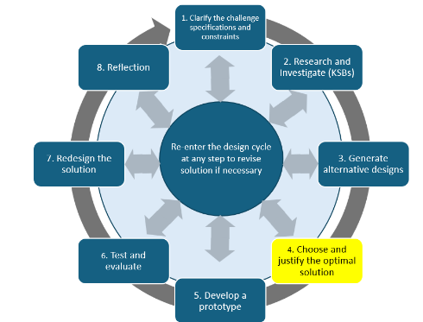
Review your 3 alternative designs.

You may:
  - choose the design you think will work best, or
  - combine the strongest features from multiple ideas to create a new best design.

Evidence: Submit a final design sketch that includes approximate dimensions, sensor location, Walk/Don’t Walk indicators, and major component placement.

Explain why your team selected or created this design using at least two design reasons, such as clarity, reliability, ease of use, feasibility, or component placement.

Optimal Crosswalk System—Part 2—Crosswalk Code
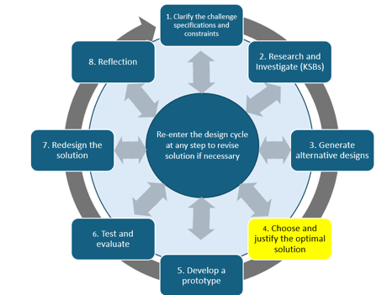
Now you need to put everything together and create a Crosswalk Code that will allow a person to safely cross the street. Often times as you write and test the code, you need to make changes. Use your KSB 4 pseudocode and KSB 2 timing calculations as the plan for your final program.

Build the code so the light sensor triggers the complete sequence: safety delay, Walk, blinking Don’t Walk, and return to steady Don’t Walk.

Expect to revise your code while testing. A change is not a mistake — it is evidence that you are using test results to improve the system.

Evidence:
  - your pseudocode
  - screenshot of an early working version of the code
  - screenshot of the final code
  - a short explanation of at least one change you made and why

Develop Your Prototype
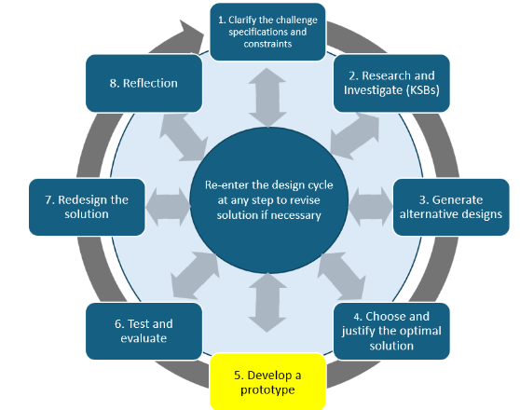
Now it’s time to build the crosswalk light system. This includes assembling all the necessary components: writing the code, setting up the Hummingbird controller, wiring the LEDs for the “Walk” and “Don’t Walk” signals, and connecting the light sensor, which functions as the push button.

As you build, you may change the physical design if you discover that another arrangement works better. You may adjust dimensions, materials, sensor placement, indicator placement, or other physical features.

Evidence:
- at least one clear photo of the completed prototype
- a second photo showing the component/sensor setup if it is not visible in the first photo

• a brief note describing any major changes you made while building and why

Test and Evaluate
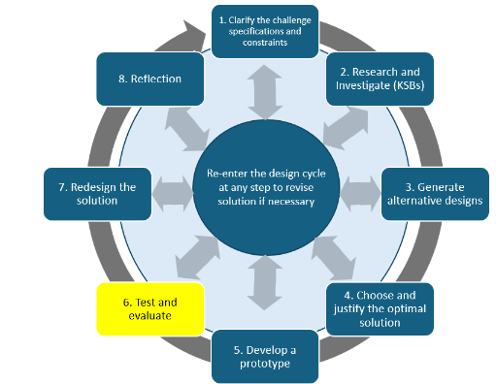
Engineers test systems to find out whether they work reliably, not just whether they work once.

Run at least 3 complete test trials. During each trial, test the full sequence from sensor activation through the return to steady Don’t Walk.

Check:
  - Does the sensor trigger reliably?
  - Does the safety delay match your planned timing?
  - Does Walk stay on for the planned crossing time?
  - Does Don’t Walk blink for 3 seconds?
  - Does the system return to steady Don’t Walk and reset correctly?

If you make a meaningful change after a trial, test the system again.

Evidence: Submit the completed test table and a short summary explaining what worked consistently, what did not work as expected, whether the design met the specifications, and what changes you made.

Trial | Expected Sequence | Actual Result | Change Made
Trial 1
Trial 2
Trial 3
Additional Trial
Checkpoint: Before moving on, make sure you completed at least 3 full trials and recorded what actually happened during each sequence.

Redesign Ideas
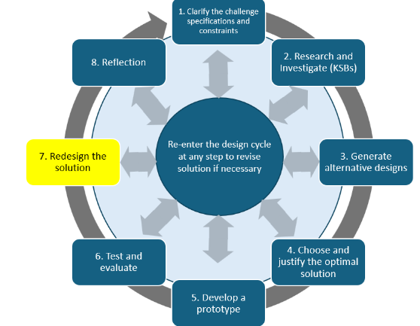
Engineers always seek to make devices more efficient, to function better, and perform more effectively. What are your ideas as to how to improve your design?

Review your test results and identify at least one change that could improve the crosswalk system. The change might involve the code, timing, sensor placement, indicators, structure, or clarity for the user.

Evidence:
  - one redesign idea
  - a short explanation of why the change could improve the system

If time and materials allow, make the change and test it again. If you do not make the change, explain what you would change and what you expect to improve. If you do make it, briefly describe what happened after the new test.

Reflection
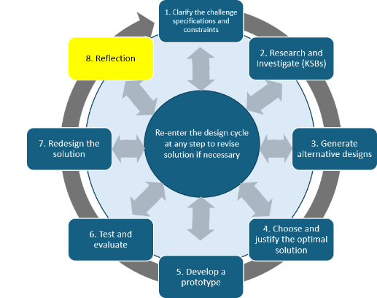
What did you learn? You can think about coding, how crosswalks work, and issues to consider when designing a crosswalk. How have your own experiences influenced your design?

Even if you completed the challenge as a team, each team member will complete an individual reflection.

Use specific examples from the project to respond to these questions:
- What is one important thing you learned about timing, sensors, LEDs, or code?
- What part of the project was most challenging, and how did you respond?
- What did you contribute to your team’s design?
- What changed from your preliminary idea to the final prototype?
- How did thinking about different pedestrians or your own experiences influence the design?
- If you had more time, what would you improve next?

Evidence: Submit your own reflection as a short written response, audio response, video reflection, or another format approved by your teacher.

Assessment Rubric: Design and Engineering

Criteria | 1 | 2 | 3
Alternative Designs | One design idea is shown. The sketch or explanation is incomplete. | Two design ideas are shown with sketches and brief explanations. | At least three meaningfully different design ideas are shown. Each includes a sketch and enough detail to explain how a pedestrian would use the system. The final design is selected or created using at least two design reasons.
Crossing Time Calculations | Some timing calculations are missing, unclear, or do not include units. | Vehicle braking/reaction time and pedestrian crossing time are calculated with most steps shown. | Reaction, braking, safety-delay, crossing, and blinking-phase calculations are complete, accurate, and shown step by step with units. Timing choices are explained, including any additional crossing time added.
Sensor Operation Code | An LED can be controlled, but the light sensor does not reliably trigger the output or the evidence is incomplete. | The light sensor controls an LED and the code works at the planned trigger value. | The light sensor reliably controls an LED. Code or explanation clearly shows how the sensor value controls the output, and sample readings demonstrate understanding of the trigger threshold.
Final Design and Documentation | A prototype and code are created, but the complete crossing sequence does not yet work as planned. | The prototype completes most of the planned sequence. Pseudocode, code, and photos show how the system works. | The prototype reliably completes the full sequence: sensor trigger, safety delay, Walk, 3-second blinking Don’t Walk, and return to steady Don’t Walk. Documentation includes pseudocode, final code, prototype photos, and an explanation of changes made during development.
Testing and Evaluation | Limited testing is completed, or results are not recorded clearly. | At least two complete trials are conducted and results identify a success or problem in the sequence. | At least three complete trials test the full system sequence. Expected and actual results are recorded, the design is evaluated against the specifications, and changes made or proposed are supported by test evidence.
Reflection on Learning | The individual reflection gives general statements with few project examples. | The individual reflection explains specific learning and describes the student’s contribution to the project. | The individual reflection uses specific examples to explain learning, challenges, contributions, design changes, consideration of users, and possible next improvements.

