

Designing a Robot Maze
Student Edition
2026



Grant Number – 2341962

Designing a Robot to Navigate a Maze

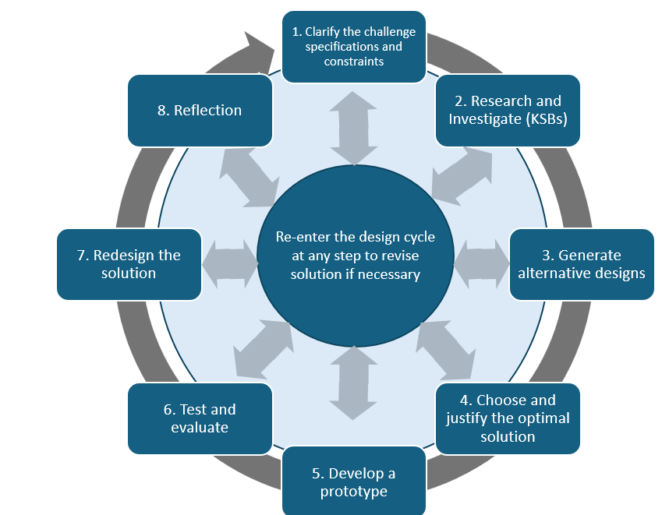
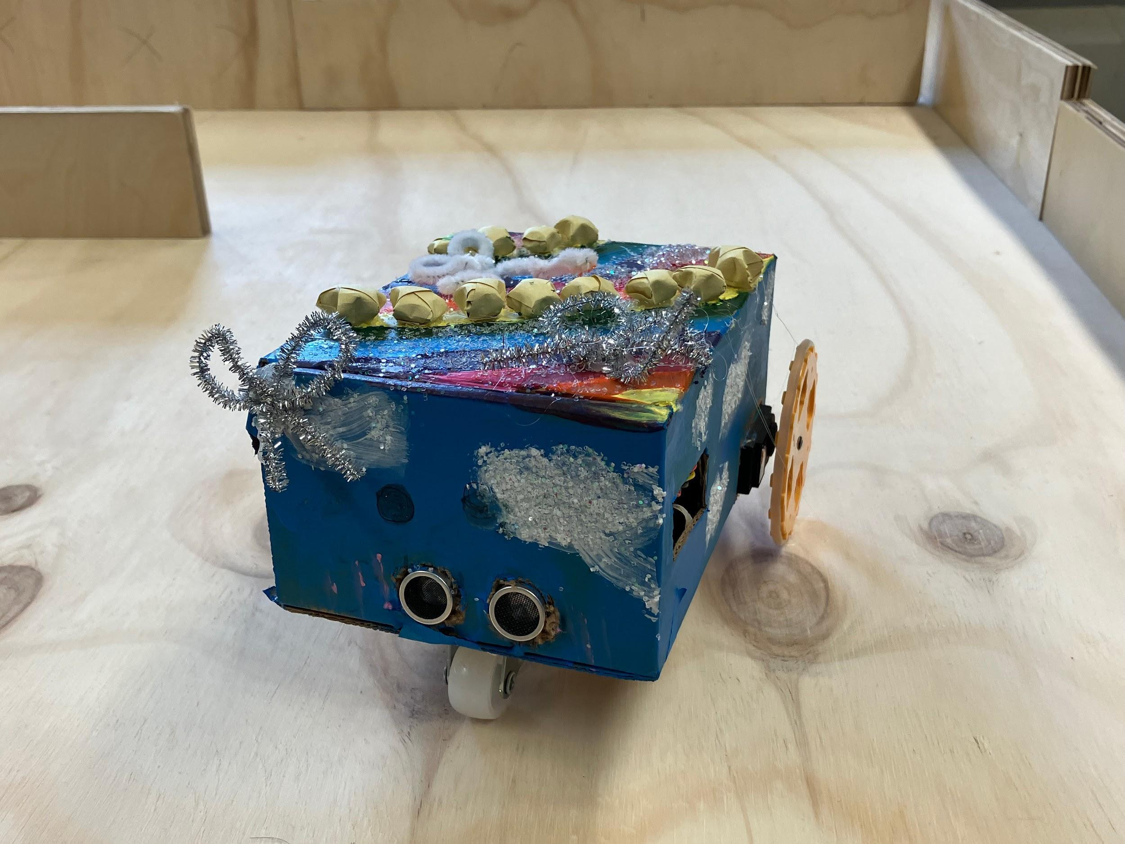

Challenge

Robots are used in many different applications. One of the many applications is inside a hospital to either deliver medications or supplies to a nurse’s station or to sanitize the facility on a nightly routine. In both cases the robot must navigate the halls and floors of the building avoiding all obstacles in their way and in the case of the medication delivery arrive at the intended location.

Your robot should use sensor information and programmed movement to make decisions as it travels through the maze. The goal is not simply to reach the exit once, but to create a system that can do so reliably.

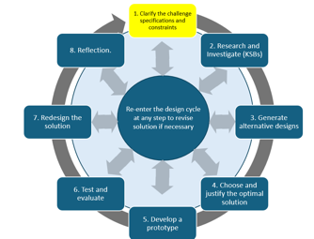
Specifications (what does the design have to do)

You and your team have been asked to design a robot that will independently navigate through a maze. You will use up to two rotation servos and a distance sensor. You will have access to the “floor plan” (the maze which is constructed of cardboard or scrap 2x4 to create the walls of the maze) prior to programming your robot. Your robot will start at a designated starting point and navigate to the exit.

Before you begin designing, identify the specifications your robot must meet.

Example specification: The robot must travel from the starting point to the maze exit without being manually controlled during the run.

Evidence: Create a short list of the required specifications for your robot.

Constraints (things that limit your solution)

The maze will consist of “passageways” that are no wider than a foot.

Identify the limits your team will work within, including the maze dimensions, available Hummingbird components, materials, class time, and any teacher requirements.

Evidence: Create a short list of the constraints that will affect your design.

Materials

Cardboard
Tape
Hummingbird Bit Controller
Battery Pack with 4 AA batteries
Hummingbird rotation sensors (up to 2) and servo hardware
Hummingbird distance sensors (up to 2)
Two Wheels
Ping Pong Ball (something to act as a “3rd leg” and allows for easy turning, i.e. swivel wheel)
Markers/Art Supplies to decorate the robot
Glue gun
Scissors etc.

Materials for the Maze:
scrap 2x4s to form walls of the maze
You do not need to use every available material. Choose materials that help your robot move reliably and fit within the maze.

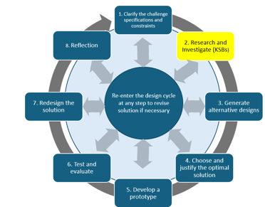
Knowledge and Skill Builders (KSBs)

KSB 1 Building a Mobile Robot

Study the BirdBrain Box Rover example to see one way a simple mobile robot can be constructed.
My First Rover

Here is a link to a tutorial on how to build a simple Box Rover:

https://learn.birdbraintechnologies.com/hummingbirdbit/build/rover/1-1

Before building, create a preliminary sketch of your robot.

Your sketch must show:
- approximate overall size
- location of both drive wheels
- location of the third support point
- planned servo placement
- planned distance-sensor placement
- Hummingbird controller and battery location

Approximate dimensions are enough at this stage. Use the measurement system your teacher requires.

Evidence: Submit the labeled preliminary sketch and a short explanation of how your robot will move and sense obstacles.

KSB 2 How Rotation Servos Work

A rotation servo is a motor that can rotate at different speeds.

Use the BirdBrain tutorial to learn how a rotation servo responds to different speed values. :

https://learn.birdbraintechnologies.com/hummingbirdbit/snap/program/10-1

Follow the directions for programming the rotation servo.

Test one servo first, then connect and control a second servo.

Experiment with positive, negative, and different speed values so you can see how direction and speed change.

Evidence:
- screenshot of code controlling two rotation servos
- short note describing what positive and negative values do on your robot

Do not worry yet about perfect straight-line movement. The goal of this KSB is to understand servo control.

KSB 3 How Distance Sensors Operate

A distance sensor is a component that collects data based on your distance from the sensor. The range of the Hummingbird distance sensor is 1 to 260 cm.

Use the BirdBrain tutorial to learn how the distance sensor reports the distance to an object.
https://learn.birdbraintechnologies.com/hummingbirdbit/snap/program/15-1

Follow the directions for programming the distance sensor and have the Hummingbird play a sound when an object is detected at a specified distance away (i.e. <10 cm).
Create a simple program that responds when an object enters a distance range chosen by your team.

Test the sensor at several distances before deciding on a useful obstacle-detection value.

Evidence:
- screenshot of the distance-sensor code
- at least 3 sample distance readings
- one short statement about what you noticed about the sensor response

Extension: Change the response distance and compare how the robot would behave with an earlier or later warning.

KSB 4 Getting the Robot to Move Forward and Backward

If you have not yet built your robot, do so now. You will need a swivel wheel or half a ping pong ball to serve as the third “leg,” which will enable the robot to easily turn. Once you have a robot built, you are ready to code the Hummingbird so that the robot moves forward and backward.

You will need two rotation servo blocks set at a percentage greater than 0.

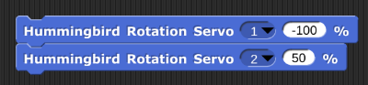

Experiment with these two blocks. Fill in the table below, then answer the questions that follow. Pay close attention to the direction in which the wheel is moving (i.e. does the right wheel rotate such that the top of the wheel moves forward?)

Rotation Servo #1 Speed | Rotation Servo #2 Speed | Observations
100 | 100
0 | 0
-100 | -100
100 | 0
0 | 100
50 | 50
-50 | 50

Which wheel does the Rotation Servo #1 control? ______________(Right or Left)

Which wheel does the Rotation Servo #2 control? ______________(Right or Left)

What does the negative sign in front of the speed do to the rotation of the servo?

What happens when both speeds are positive?

What happens when both speeds are negative?

What happens when one speed is positive and the other is negative?

What happens when the speeds have different absolute values? (i.e. 40 and 60 or -35 and 70)?

Complete the table below for each scenario based on your findings above:

Scenario | Rotation Servo #1 Speed | Rotation Servo #2 Speed
Move forward
Move backward
Turn Left
Turn Right

Evidence: What are some variables that affect how your robot moves forward in a straight line?

KSB 5 Getting the Robot to Turn 90 Degrees Left or Right

Now you are ready to code the Hummingbird so that the robot turns left or right.

There are several ways to make this happen:
- One wheel turning
  - Set one servo to turn for an amount of time such that it turns 90 degrees. One example of code is:
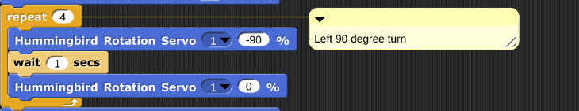
Note: The above code worked with a particular set of rotation servos assembled in a particular way. The above code may need to be adjusted depending on your rotation servos and how your robot is built and assembled.

- Both wheels turning
  - How can you change the code from part A to include the second rotation servo?

  - Why would two wheels be better/worse than one wheel turning?

  - Which method do you prefer? One wheel turning or two? Why?

You will need to experiment with your particular robot to get the correct speed and duration for your robot to make a 90 degree turn.

What are some variables that affect how your robot turns?

Can you control any of those variables? If so, what controls did you introduce?

Evidence:
- code for a 90-degree left or right turn
- the speed and timing values used
- short explanation of which turning method your team prefers and why

Extension: Calibrate both a left and a right 90-degree turn.

KSB 6 Driving and Avoiding Obstacles

Use the BirdBrain tutorial to combine movement and sensing.
https://learn.birdbraintechnologies.com/hummingbirdbit/snap/program/23-1

Now create code that moves your robot forward until there is an obstacle detected in front.

- Create code that:
• moves the robot forward
• continuously checks the distance sensor
• stops or changes behavior when an obstacle is detected
Test several detection distances and choose one that gives the robot enough room to react.
Evidence:
- • screenshot of working movement + sensor code
- • chosen obstacle-detection distance
- • short explanation of why that distance works for your robot

Extension: Instead of stopping, program the robot to begin a turn when an obstacle is detected.

KSB 7 Thinking Like a Computer

Computers are controlled by code, in this case the computer program you create will independently navigate a robot through a maze without hitting any obstacles. This is similar to you walking through a crowded room or changing classrooms between class periods. You must avoid the people standing in front of you and turn corners to get to your next classroom. When you see a person in front of you, what do you do? Your brain tells your body to stop, you scan the area for a way around the person and then your brain instructs your legs to turn left or right to move a step or two turn again and then move forward around the person. You must program your robot to do the same when detecting an obstacle.

Think about what you want to happen step by step. This is how the computer reads the directions you give it through the code that you write. Go back to the challenge statement and review what is supposed to happen.

Pseudocode is a description of the steps in an algorithm using a mix of programming language and informal self explanatory notations of actions and conditions. Using pseudocode, indicate the sequence of events below.

Your pseudocode should describe what the robot should do:
- when the path ahead is clear
- when an obstacle is detected
- when it needs to turn
- after the turn is complete
- until the maze exit is reached

Keep the pseudocode in plain language. It should explain the logic clearly enough that another team could follow the sequence.

Evidence: Submit the pseudocode for your planned maze-navigation algorithm.

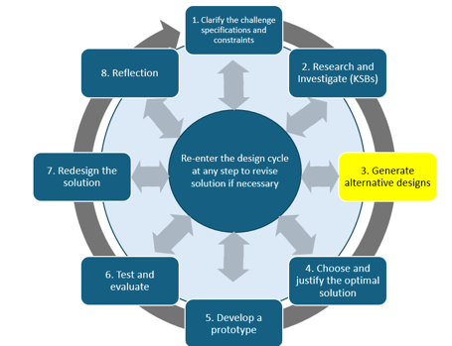
Building the Robot

Alternative Designs

You need to build a robot that can independently navigate a maze. You will be using cardboard to make the robot. Create several designs, taking the time to sketch out your ideas, and include a brief explanation of each design. This type of brainstorming and planning is beneficial in the long run, enhancing your overall efficiency.
Create at least 3 meaningfully different robot designs before selecting your final approach.

Each design must include:
- labeled sketch
- approximate size
- wheel and servo placement
- sensor placement
- controller/battery placement
- short explanation of how the design supports movement and obstacle detection

Evidence: Submit 3 design sketches with brief explanations.

At this stage you are exploring possibilities. Do not choose the final design yet.

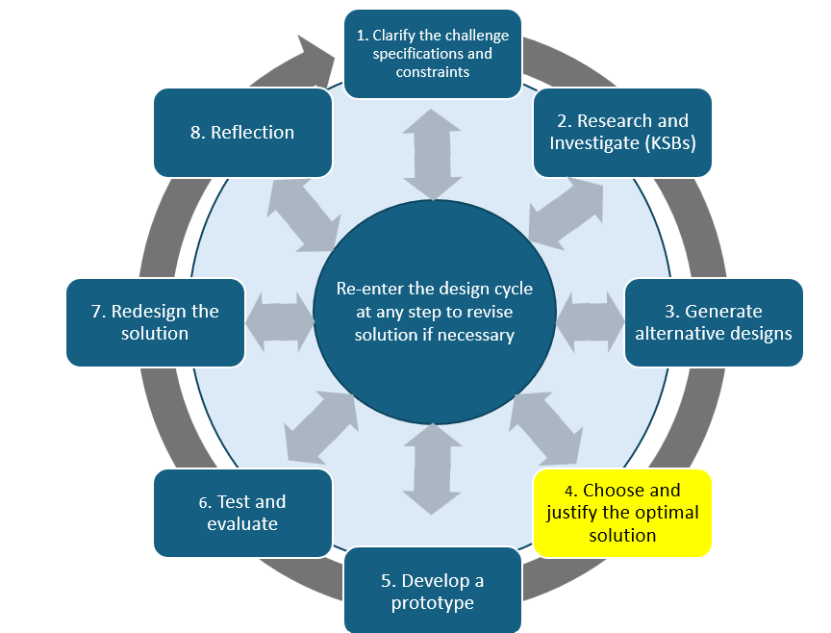
Choose The Best Design
Choose the design that will satisfy all the specifications within the constraints and give you the best outcome. This is the optimum design. Explain why you think this design is a better choice than the alternatives. Take a picture of your final solution and paste it here.

Review your 3 alternative designs.

You may choose one design as drawn or combine the strongest features from several ideas to create your best design.

Evidence:
- final labeled sketch
- approximate dimensions
- component placement
- short explanation using at least two design reasons, such as stability, turning ability, sensor position, size, reliability, or ease of construction.

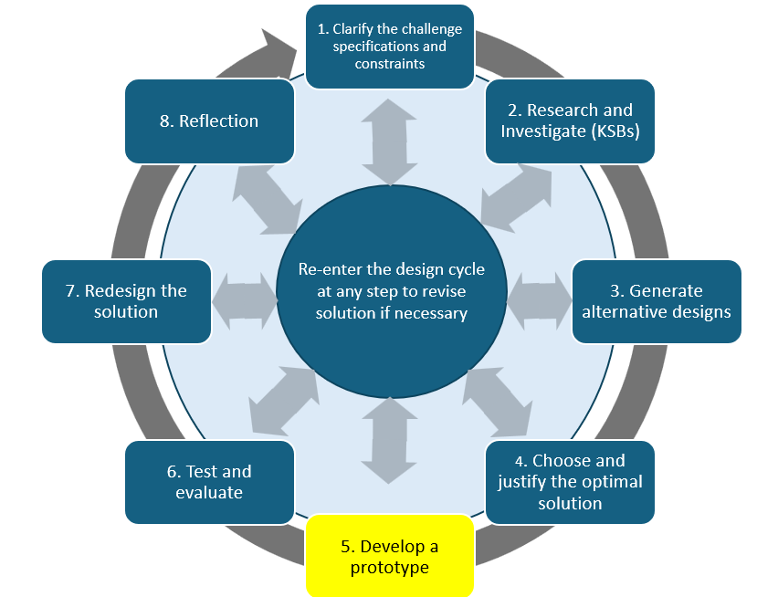
Designing and Programming Your Robot

Now you need to put everything together and create code that will successfully navigate your robot through a maze, avoiding all obstacles. Programmers and Engineers often build a prototype that is not the final solution. As you write and test your code, you will need to make changes. This is what we call the iteration process.

Use your pseudocode and KSB results to build the complete navigation program.

Expect to revise both the robot and the code during development.

Evidence:
- initial version of the maze-navigation code
- final version of the code
- photo of the completed robot
- short explanation of at least one meaningful change and why it was made

You may change the physical design during construction if testing shows that another approach works better.

Test and Evaluate
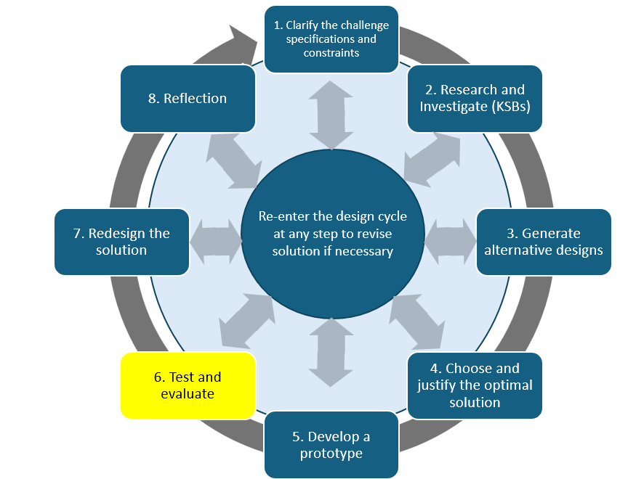
Did your solution work and meet the design specifications? .
Test the complete robot in the maze at least 3 times.

For each trial, record:
- whether the robot reached the exit
- where it had difficulty, if anywhere
- whether it contacted a wall or obstacle
- any code or physical change made before the next trial

Evidence: Submit a simple test table plus a short testing summary explaining what worked consistently, what did not, and whether the robot met the specifications.

Checkpoint: After a meaningful change, run another complete maze trial.

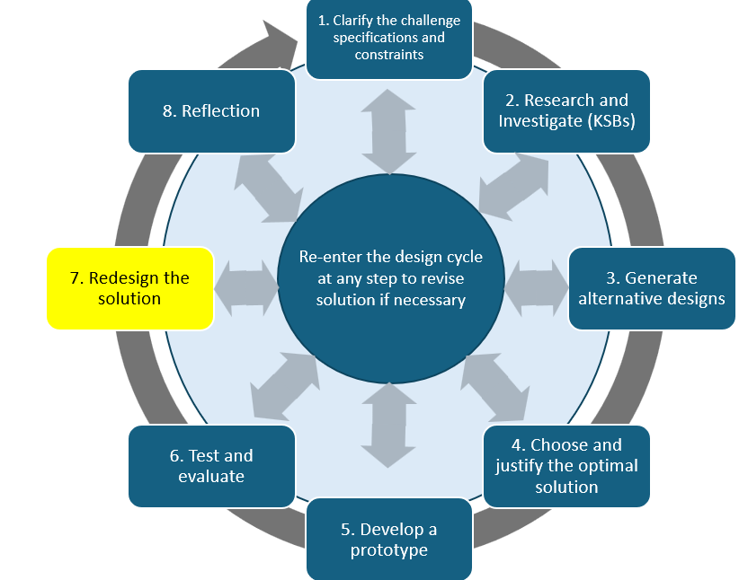
Redesign your solution

Engineers do not go with the first design; they often go back and redesign their first solution to make it better, more efficient, make it perform well, or address a specification that was added after the start of the design process.

What are your ideas as to how you would improve your design?

Use your test results to identify at least one improvement to the robot or code.

The redesign might involve wheel alignment, sensor placement, turning values, robot size, construction, or the navigation algorithm.

Evidence:
- one specific redesign idea
- explanation of why the test evidence suggests it would help

If time allows, make the change and test again. If you do not make the change, explain what you predict would improve.

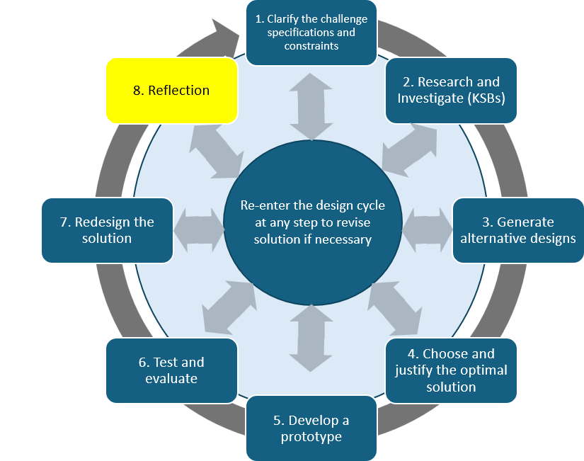
Reflection

Even if the project was completed as a team, each team member completes an individual reflection.

Respond to:
- What is one important thing you learned about programming movement or sensors?
- What was the biggest challenge and how did you respond?
- What did you contribute to the team’s robot?
- What changed from the first design/code to the final version?
- If you had more time, what would you improve next?

Evidence: Submit your own reflection.

Self-Reflection

Criteria | 1 | 2 | 3
Alternative Designs | One design idea is shown with limited detail. | Two design ideas are shown and one is selected with a reason. | At least three meaningfully different designs are shown; the final design is selected or synthesized using at least two design reasons.
Servo Operation | Robot movement is limited or inconsistent. | Code intentionally moves the robot forward and backward and begins controlled turning. | Code reliably controls forward, backward, left, and right movement; values are calibrated for the team’s robot and logic is readable.
Sensor Operation | Distance-sensor code is present but is not yet connected to robot behavior. | Sensor data controls at least one movement response. | Sensor data reliably controls obstacle response in the complete navigation program; the chosen detection distance is explained.
Final Design | Photo and basic code are provided with limited explanation. | Final robot and code are documented with a brief explanation of how the system works. | Final robot, initial/final code, and meaningful changes are documented; explanation connects construction, sensing, and navigation logic.
Test and Evaluation | Limited testing with little evidence. | Multiple trials are completed and major results are described. | At least 3 complete maze trials are recorded; results identify patterns, failures, and changes made or proposed.
Reflection | Reflection is general and gives few project examples. | Individual reflection explains specific learning and contribution. | Individual reflection uses specific examples to explain learning, challenge, contribution, iteration, and a next improvement.
Additional Resources

Real World Applications:
Cleaning Robots Reduce Infections in Hospitals and Public Spaces
Robotic Technologies: Cleaning Trends for Healthcare Facilities

