Robotic Arm Design Challenge
In factories, laboratories, and even space stations, robotic arms perform tasks that are too dangerous, repetitive, or precise for humans. These mechanical arms can rotate, lift, and grip—just like a human arm—but they're powered by motors and controlled by code.
In this challenge, you will act as an engineer and prototype your own robotic arm. Your arm will be made from cardboard and powered by servo motors from the Hummingbird Kit. The arm must include at least three joints and be able to perform this task automatically using a programmed motion sequence to move an object from Point A to Point B..
Design, build, and program a cardboard robotic arm that can automatically move an object from Point A to Point B.
Your robotic arm must:
• include at least three moving joints or motions
• rotate, lift, and grip
• use a programmed motion sequence
• pick up, move, and release an object
• complete the task without being manually repositioned during the sequence
• be stable enough to repeat the task
The goal is not simply to make the arm move. The goal is to create a coordinated system in which the structure, joints, servos, gripper, and code work together reliably.
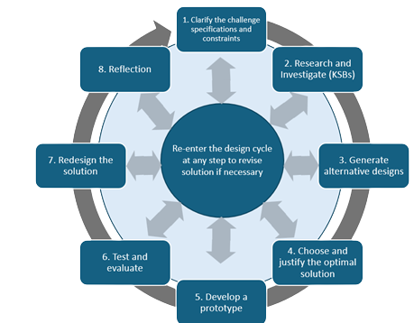

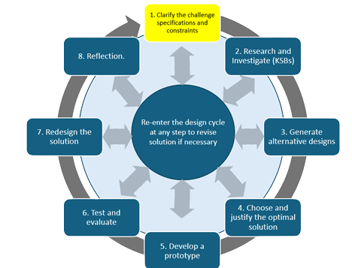
Specifications: (what does the design need to do)
Before designing, identify the requirements your robotic arm must meet.
Example specification: The arm must pick up an object at Point A and release it at Point B during one programmed sequence.
Evidence: Create a short list of the required specifications.

Constraints: (things that limit your solution)

Identify the limits your team must work within, including available materials, number and type of servos, object size and weight, workspace, class time, and teacher requirements.
Evidence: Create a short list of the project constraints

Materials
- Corrugated cardboard sheets.
- Brass fasteners
- Tape (masking or painter's)
- Low-temp hot glue gun & glue sticks
- Scissors or box cutters
- Hummingbird Kit (servos, wires, optional sensors)
- Computer with access to Birdbrain Snap Programming
- Ruler and pencil
- Storage bags or folders for parts
- Other teacher approved materials

You do not need to use every available material. Choose materials that support a stable structure, secure servo mounts, and smooth joint movement.

Robotic Arm Project Rubric
Category | 1 – Beginning | 2 – Developing | 3 – Proficient
Alternative Design | Only one idea considered; no evidence of comparing options. | Two ideas considered with some discussion of strengths/ weaknesses. | Multiple ideas explored with clear comparison and strong justification of choice.
Servo Operation Coding | Code missing, incomplete, or not functional. | Code runs with partial success; some errors in movement or logic. | Code works reliably; servos respond smoothly and consistently.
Final Design & Documentation | Final build incomplete; little or no documentation / sketching. | Design mostly complete; some sketches, labels, or notes included. | Design complete, stable, and clearly documented with labeled sketches and explanations.
Testing & Evaluation | No testing or results recorded. | Some testing done; limited results or weak evaluation. | Thorough testing; results recorded and used to guide improvements.
Build & Engineering | Build fragile, misaligned, or non-functional. | Build mostly stable; some weaknesses in joints or servo mounts. | Build sturdy, stable, and functional; joints and servos secure and smooth.
Reflection on Learning | Reflection missing or very brief/superficial. | Reflection includes a basic summary of what was learned. | Reflection is thoughtful and detailed; shows insights into challenges, solutions, and Engineering process.

Knowledge and Skill Builders (KSBs)

KSB 1: How Do Robot Arms Move?
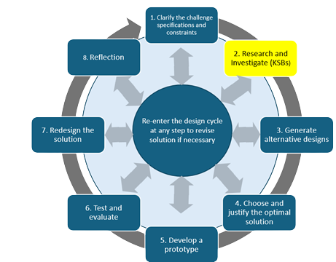
Understand and identify the types of robotic arm movement: base rotation, joint/lift movement, and gripper motion.

Tasks:
- Study how robotic arms use connected joints to create different types of movement. (e.g., How Industrial Robot Arms Work).
- https://youtu.be/P2r9U4wkjcc?si=nDd2lciBle6bRr9N
- Complete the existing diagram activity:
• label the base, shoulder, elbow, wrist, and gripper
• use arrows to show how each part moves
• identify which movement is rotation, lifting/lowering, or opening/closing.
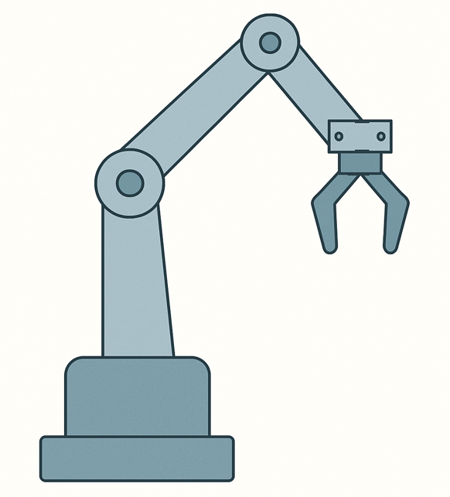

- Then compare the robotic arm to your own arm in 2–3 sentences.
Evidence:
• completed labeled diagram
• motion arrows
• short comparison
Checkpoint: Before moving on, you should be able to explain which part of the final robot arm will create each required motion.

KSB 2: What Makes a Great Gripper?
There are many types of grippers. Some pinch like tongs, some scoop like a shovel, some use suction, and others flex like soft fingers.
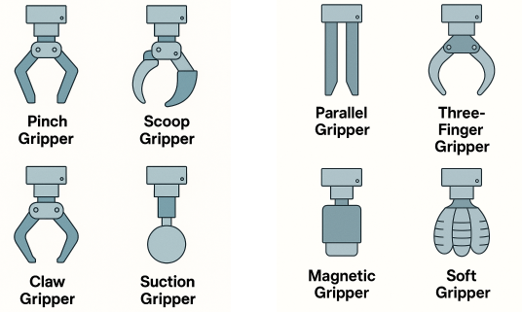
Tasks:
- Create and test at least two different gripper designs.
Test each design with at least three objects that vary in size, shape, or texture.
Record:
• whether the gripper picked up each object
• whether the object stayed secure
• how easy the object was to release
• what failed or slipped
Evidence:
• two gripper designs
• simple test results for at least three objects
• required labeled sketch of the best design
• short explanation of why that design is the strongest choice for the final arm
The final gripper may combine the strongest features of both prototypes.

KSB 3: Positional Servo Basics
Learn how a positional servo rotates to specific angles and how it’s used to control precise motion like bending joints or opening a gripper in your robotic arm.
Positional servo motors turn to specific angles (0°, 90°, 180°). That’s how we make the robot arm move!
Hummingbird Bit - Snap - Program Positional Servo https://learn.birdbraintechnologies.com/hummingbirdbit/snap/program/9-1
Tasks:
- Connect a positional servo to the Hummingbird and program it to rotate between 0°, 90°, and 180°.
- Move to 0°
- Wait 1 second
- Move to 90°
- Wait 1 second
- Move to 180°
- Wait 1 second
- Repeat
Do not force the servo beyond its physical range. A command outside the supported range may be ignored, limited, or place stress on the mechanism.
Evidence:
• screenshot of the servo code
• tested angle values
• short statement explaining how speed, timing, and load could affect a robotic-arm joint.

KSB 4: Using a Rotational Servo
Learn how a rotational servo works differently than a position servo, and how it can be used to create continuous spinning motion in your robotic arm design.
What’s the Difference?
Most servos rotate to specific angles (like 0°, 90°, or 180°). But a rotational servo spins in one direction until you tell it to stop—like a motor with a throttle.
You might use it to create spinning movement at the base of your robotic arm or in a rotating platform.
Tasks:
- Connect the Rotational Servo
Plug in the rotational servo to your Hummingbird board and make sure it’s secure.
- Program the Servo
Open your coding environment. Write code that makes the rotational servo:
  - Spin in one direction for 3 seconds
  - Stop for 2 seconds.
  - Spin in the opposite direction for 3 seconds
  - Repeat
- Adjust Speed and Direction
Try changing the speed from full power (100%) to slower speeds (e.g., 30%).
What happens when you set the value to a negative number?
- Test Applications
Evidence:
• screenshot of the rotation-servo code
• the speed and timing values tested
• a sketch or short explanation showing where the rotation servo will be used in the final arm
Important design note: A continuous-rotation servo is controlled by speed and time, not by a precise target angle. The base may require calibration and physical reference marks to stop consistently.

KSB 5: Building Strong Cardboard Joints
Learn how to build rotating joints using cardboard and brass fasteners that are strong, flexible, and ready for real motion in your robotic arm.

Why It Matters:
If your joints are too loose, your arm flops. Too tight? It won’t move. Engineers test and refine their joints, so movement is smooth, controlled, and repeatable.
Build and refine a cardboard joint that moves smoothly without excessive wobble.
Test:
• joint tightness
• side-to-side movement
• cardboard bending
• servo-mount stability
• movement under a small load
Evidence:
• photo of the joint
• short record of at least one problem found
• explanation of one improvement made
• statement identifying where the joint could be used in the final arm
The goal is controlled and repeatable motion, not simply a joint that can move.

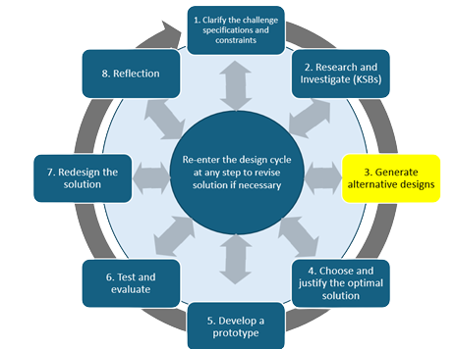
Alternative Robotic Arm Designs
Engineers don’t just dive in and start cutting—they plan. A good sketch helps you build smarter, solve problems early, and get your design approved faster. Plan your robotic arm design by drawing a clear, labeled sketch that shows how each part will move and where your servos will go.
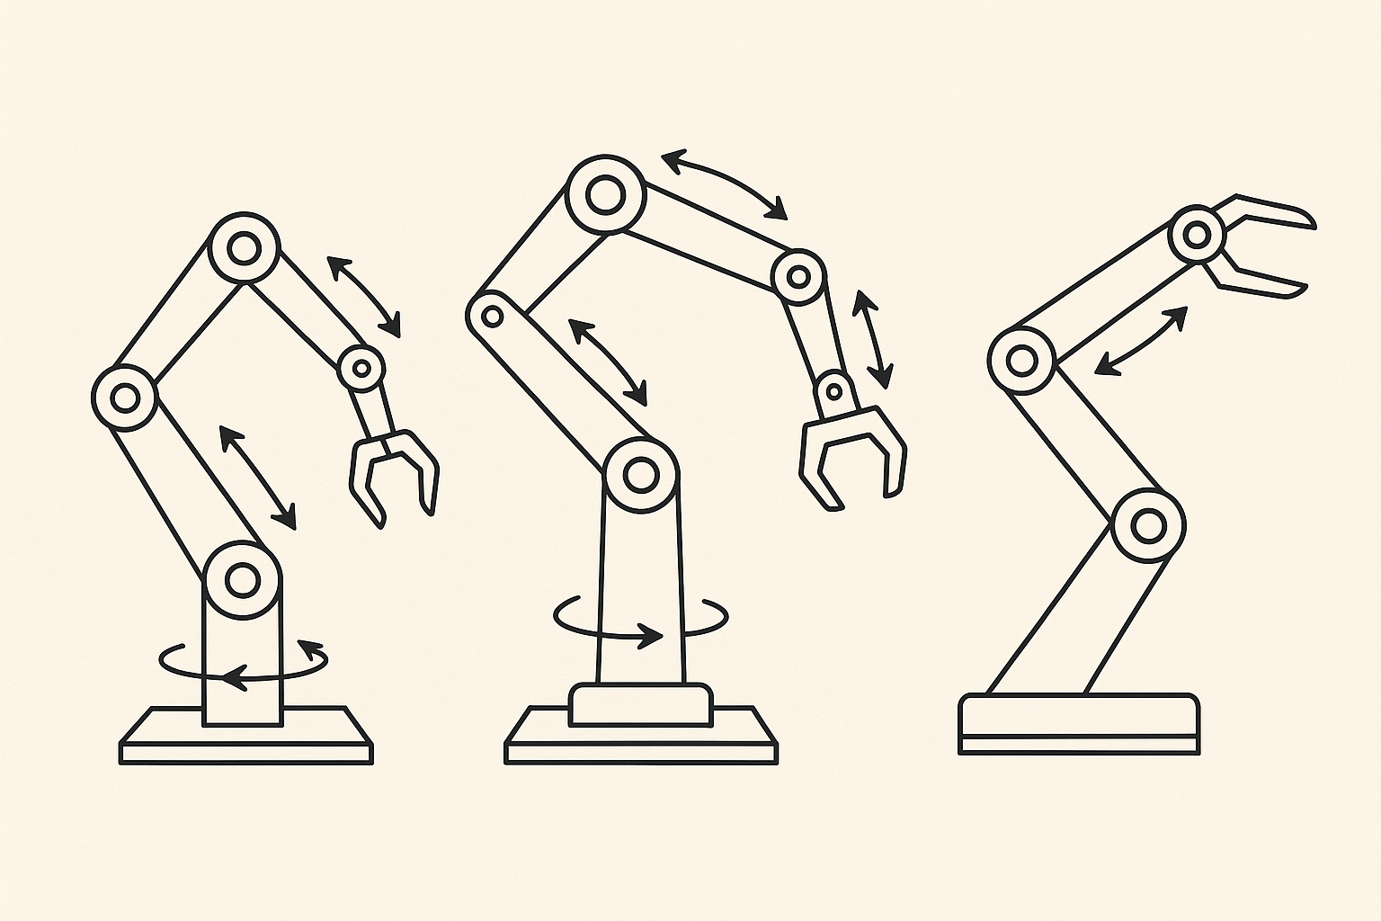
Tasks:
- Draw a Side View of Your Robotic Arm
Include:
  - Base
  - Arm segments (upper arm, lower arm)
  - Gripper
  - Servo locations
- Add Motion Arrows
Use arrows to show how each part of the arm will move:
  - Rotation (curved arrow)
  - Lift/lower (straight up/down)
  - Open/close (gripper motion)
- Label Your Parts
Clearly label:
  - Each joint (e.g., base, elbow, wrist)
  - The type of motion
  - Where servos will be mounted
- Evidence: Submit three labeled design sketches with brief explanations.
The designs should differ in more than appearance. Change the arm geometry, gripper, joint arrangement, servo placement, or movement sequence.

Optimal Robotic Arm Design
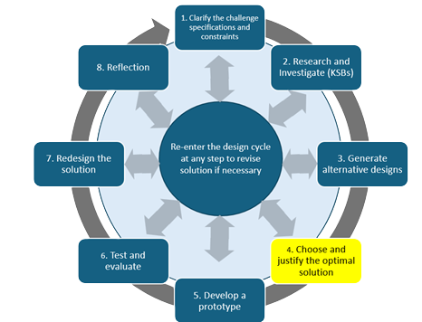
Every engineer must make tough choices. You’ve explored grippers, sketched designs, and experimented with servos. Now comes the real test: deciding which idea is worth building. This step is about thinking critically, comparing your options, and backing up your choice with solid reasoning. In engineering, it’s not about picking the “coolest” idea—it’s about picking the one that works best for the task.
Compare the three designs using the existing decision criteria:
• stability and strength
• range of motion
• gripper performance
• build feasibility
• servo placement
• likelihood of completing the Point A to Point B task
You may select one design or combine the strongest features from multiple ideas to create the best final design.
Evidence:
• comparison chart
• final labeled sketch
• approximate dimensions
• short explanation using at least two design criteria to justify the decision.
- Make Your Decision
Pick the design that balances performance, feasibility, and creativity. Engineers often choose the “best compromise,” not the perfect solution.
- Justify Your Choice
Write 3–4 sentences that explain your reasoning. Example:
“We chose Design B because it is the most stable and gives us a strong gripper. Even though Design A had more range of motion, it was too weak to pick up objects. Design B meets more of our criteria and is more likely to succeed.”

Optimal Robotic Arm Code
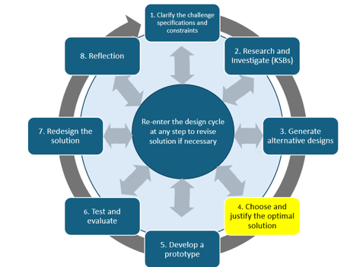
Now you need to put everything together and create a code that will allow your arm to move in all three ways. Often as you write and test the code, you need to make changes.

Before writing the complete program, create pseudocode for the full transfer sequence.
The pseudocode should show:
• move to Point A
• open the gripper
• lower or position the arm
• close the gripper
• lift the object
• rotate or move to Point B
• lower or position the arm
• release the object
• return to a useful starting position
Then build and test the code.
Evidence:
• pseudocode
• screenshot of initial code

Develop your Prototype
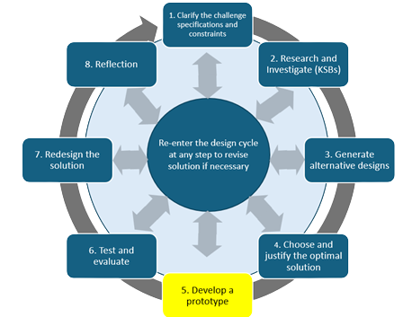
Turn your design into a working prototype using cardboard, servos, and your creativity. Focus on structure, stability, and function. This is where your planning meets the real world. It’s not just about making something that looks cool, it must work. Strong joints, clean cuts, stable mounts, and smart construction all matter.

Build the robotic arm using the final design as the starting plan.
Build and test one subsystem at a time:
• base rotation
• arm structure and lifting joint
• second joint or wrist movement
• gripper
• complete programmed sequence
You may adjust dimensions, joint locations, servo mounts, gripper geometry, or code if testing shows a better solution.
Evidence:
• photo of each major subsystem
• photo of the complete arm
• screenshot of the integrated code
• brief note describing any major design change made during construction and why.

Redesign and Improve Your Robotic Arm
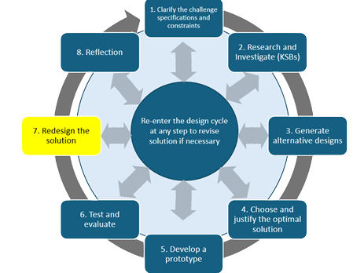
No design is perfect on the first try. Engineers expect failure, testing, and frustration—it’s part of the process. The key is what happens next: redesign. After testing, you’ll take what worked, fix what didn’t, and make your robotic arm stronger, smoother, and more reliable. Redesign isn’t starting over—it’s building smarter from what you’ve already learned.

Test the complete robotic arm with at least five full Point A to Point B trials.
For each trial, record:
• successful pickup?
• object remained secure?
• arm reached Point B?
• successful release?
• arm returned to the starting position?
• problem observed or change made?
Use the same object for the required trials so the results can be compared fairly. Additional objects may be tested as an extension.
Evidence:
• completed test table
• short testing summary explaining reliability, repeated failure points, and whether the design met the specifications
Checkpoint: After a meaningful code or structural change, run another complete trial.

Redesign Your Robotic Arm
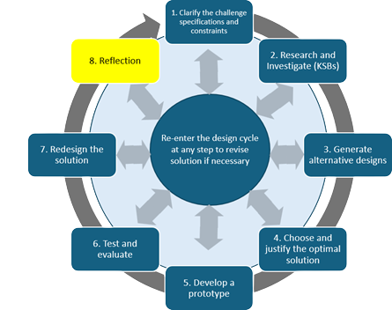
No design is perfect on the first try. Engineers expect failure, testing, and frustration—it’s part of the process. The key is what happens next: redesign. After testing, you’ll take what worked, fix what didn’t, and make your robotic arm stronger, smoother, and more reliable. Redesign isn’t starting over—it’s building smarter from what you’ve already learned.
Combine the duplicate redesign sections into one section.
Use the test results to identify the most important problem affecting performance.
Your redesign may address:
• unstable base
• weak or misaligned joint
• loose servo mount
• bending cardboard
• unreliable gripper
• poor range of motion
• timing or sequencing errors
Evidence:
• at least one specific redesign
• explanation connecting the change to test evidence
• updated sketch, photo, or code as appropriate
• results from retesting, if the redesign is implemented
If time does not allow implementation, explain the proposed change and predict how it would improve performance.

Reflection
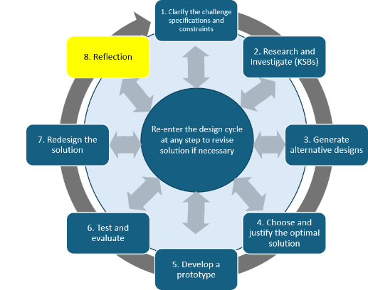
Even if the robotic arm was completed as a team, each team member completes an individual reflection.
Respond to:
• What did you learn about robotic-arm movement, joints, servos, grippers, or coding?
• What was the most difficult part to make reliable?
• What did you personally contribute?
• What changed from the first design or code to the final system?
• How did testing influence the redesign?
• If you had more time, what would you improve or automate next?
Evidence: Submit your own reflection in a teacher-approved format.

Robotic Arm Project Rubric
Category | 1 – Beginning | 2 – Developing | 3 – Proficient
Alternative Design | One design idea is shown with limited comparison or detail. | Two designs are shown and compared using at least one criterion. | At least three meaningfully different designs are shown; the final design is selected or synthesized using multiple criteria and clear evidence.
Servo Operation Coding | Code is incomplete or individual servos do not respond reliably. | Servos complete most required movements, but timing, position, or coordination is inconsistent. | Pseudocode and final code coordinate base, joints, and gripper through the complete Point A to Point B sequence reliably.
Final Design & Documentation | Prototype or documentation is incomplete. | Prototype is mostly complete; sketches, photos, and code provide basic evidence. | Prototype, required sketches, subsystem photos, initial/final code, and meaningful changes are clearly documented and explained.
Testing & Evaluation | Limited testing or no useful results are recorded. | Several trials are completed and major successes or problems are described. | At least five complete trials are recorded in a structured table; patterns are analyzed and used to support changes or redesign decisions.
Build & Engineering | Build is unstable, misaligned, or unable to complete the task. | Build completes part or most of the task but has weaknesses in stability, joints, mounts, or gripping. | Build is stable and functional; joints and servo mounts are secure, movement is smooth, and the arm repeatedly completes the required transfer.
Reflection on Learning | Reflection is general, incomplete, or provides few examples. | Individual reflection explains specific learning and contribution. | Individual reflection uses project evidence to explain learning, challenge, contribution, iteration, testing, and a next improvement.

