

Designing a Treasure Chest

Student Edition
2026



Grant Number – 2341962

Treasure Chest with a Digital Lock

Challenge

You and your team have some goodies to hide from peeping eyes. You want to only allow your team members to get to them! To protect your secrets, you will build a Treasure Chest that only you and they can open. This calls for a digital lock and a code that you will create to open the chest—that only you and team members know. Also, you must be able to lock and unlock the Treasure Chest. When the lock is opened, have a surprise happen, like a sound playing, lights flashing, or both. A shoe box or any box with a lid, can serve as your Treasure Chest.

Your system must:
- remain locked until the correct button sequence is entered
- use a servo-controlled latch
- be able to lock and unlock
- trigger a surprise when successfully opened, such as sound, lights, or both

The challenge is to create a lock that works reliably and a physical latch that connects the servo’s motion to the chest.

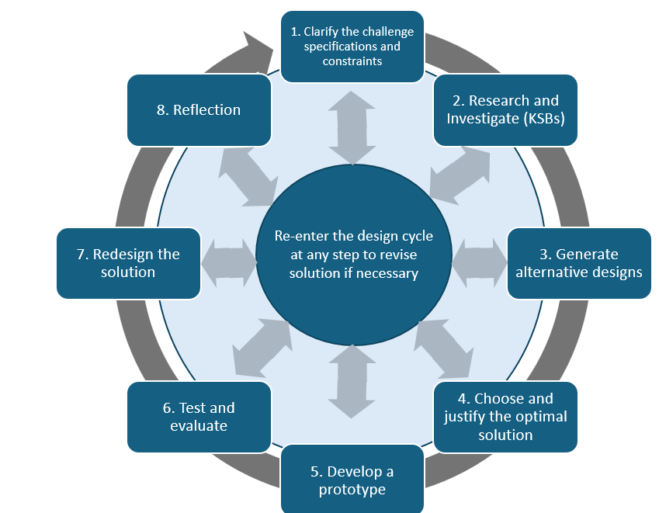

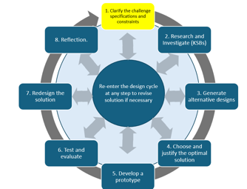
Specifications (What the design has to do)

Identify the requirements the Treasure Chest must meet.
Example specification: The latch must unlock only after the correct digital input sequence is entered.
Evidence: Create a short list of required specifications.

Constraints (things that limit your solution)
Identify limits such as materials, available Hummingbird components, chest size, class time, servo motion, and teacher requirements.

Evidence: Create a short list of constraints.

Materials

Shoebox
Glue Gun
Duct Tape
Hummingbird micro:bit
Hummingbird rotation servo
Scissors or box cutter
Hummingbird output devices for the surprise
Other teacher approved materials

Choose materials that help create a secure, repeatable latch. You do not need to use every material available.

Treasure Chest Assessment Rubric
Criteria | 1 – Beginning | 2 – Developing | 3 – Proficient
Alternative Designs | One design idea with limited detail. | Two designs are shown and compared. | At least three meaningfully different designs are shown; final design is selected or synthesized using at least two reasons.
Digital Lock Code | Code is incomplete or uses a short sequence with limited logic. | A four-or-more input sequence reliably unlocks the chest. | A four-or-more input sequence reliably unlocks, triggers the surprise, and supports returning to the locked state; logic is clearly explained.
Digital Lock Latch | Latch requires manual help or is unreliable. | Servo opens the latch automatically with some consistency. | Servo mechanism reliably locks and unlocks the chest; mechanical connection is documented and explained.
Final Design | Basic photo/code evidence is provided. | Final chest, mechanism, and code are documented with a short explanation. | Final chest, latch mechanism, initial/final code, and meaningful changes are documented with clear explanation.
Test and Evaluation | Limited testing with little evidence. | Several complete lock/unlock trials are completed and summarized. | At least 5 trials are recorded; lock, unlock, relock, and surprise performance are analyzed and changes are explained.
Reflection | Reflection is general or incomplete. | Individual reflection explains specific learning and contribution. | Individual reflection uses project examples to explain mechanism learning, challenge, contribution, iteration, surprise feature, and next improvement.

Knowledge and Skill Builders (KSBs)

KSB 1 Constructing a Treasure Chest
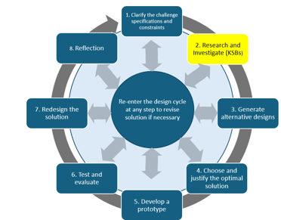
There are many ways to construct a treasure chest. One choice is to use a shoe box as the chest and find a way to lock it. You won’t be using a padlock, but rather, you will enter a digital code that opens the treasure chest.

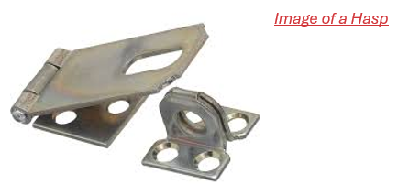
You will need a hinge for the top. One easy way to make a hinge is to use duct tape. In the picture below, part of the top has been cut so duct tape can be applied and then taped to the back of the box.
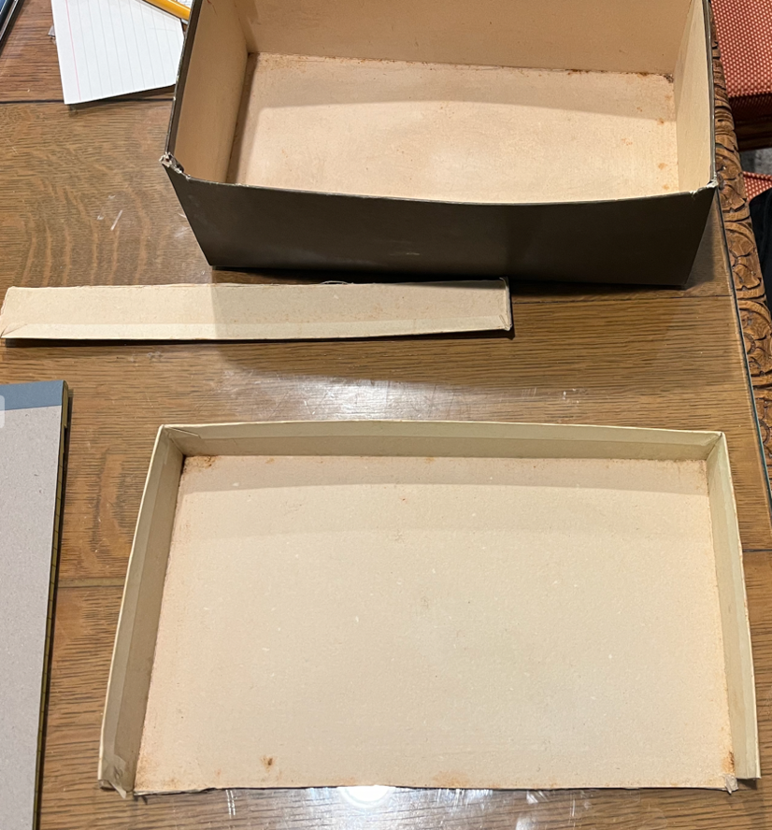

Figure 1: Shoe Box with one side of the top removed for applying a duct tape hinge.

The material from the top of the box can be used to make a hasp. A hasp is the part that swings over a latch to hold something shut—like the flap you see on a treasure chest or toolbox that you could put a lock through.
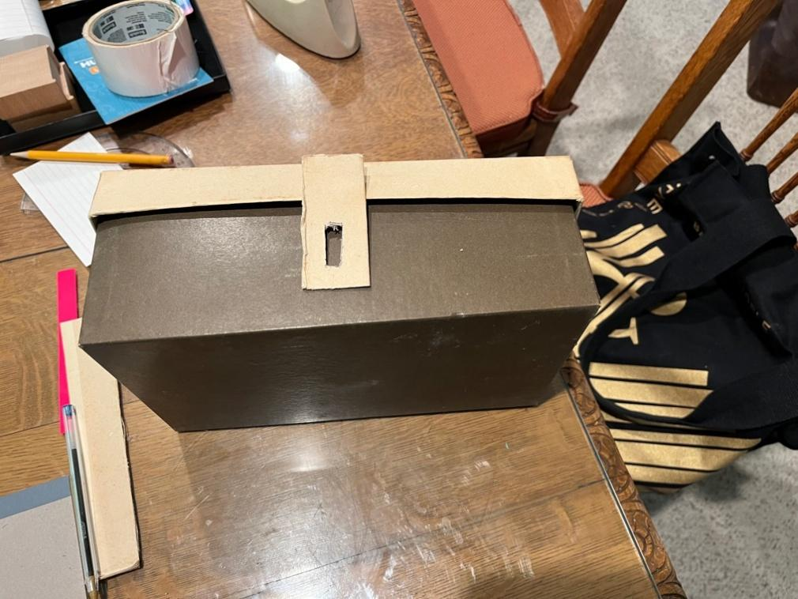

Figure 2. Shoe box treasure chest with hasp.

Next, you will need to create a latch; a pipe cleaner is one choice. You will need some flexibility in the hasp.
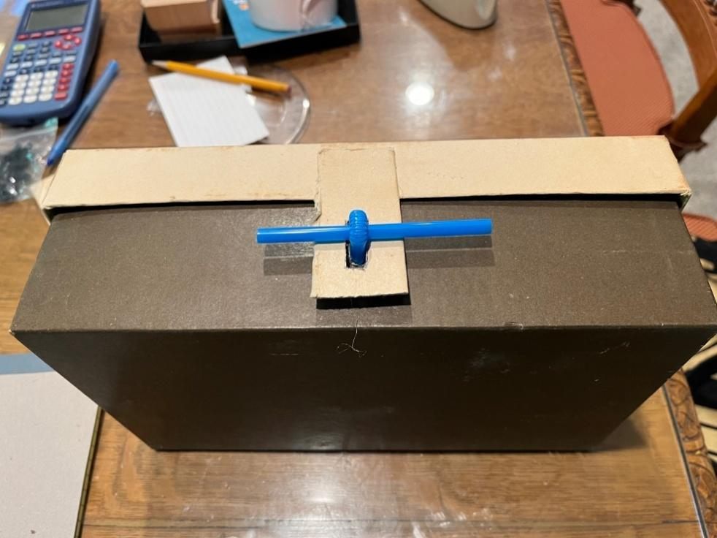

Figure 3. Shoe box treasure chest with hasp and latch.

Study the example chest, hinge, hasp, and latch to understand how the parts work together.

Create a preliminary design sketch showing:
- chest and lid
- hinge
- hasp
- latch
- planned servo location
- approximate dimensions
- direction the latch must move to lock/unlock

Then describe the sequence you expect when the correct code is entered.

Evidence: Submit the required preliminary sketch plus a short step-by-step description.

SB 2: Position Servo
The position servo rotates an arm based on the code that you provide. It could rotate a dowel, which can be used as the locking device.

Use the BirdBrain resource to learn how the position servo moves to specific angles.

Program the servo to move between a planned locked position and unlocked position, then return as needed.

https://learn.birdbraintechnologies.com/hummingbirdbit/snap/program/9-1

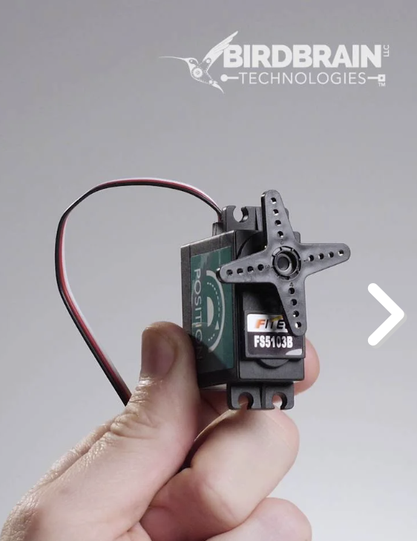

Figure 4 Position Servo

Evidence:
- screenshot of the servo code
- tested locked and unlocked angle values
- short note explaining how the servo motion could control a latch

The goal is controlled, repeatable motion rather than using a specific angle simply because it appears in an example.

KSB 3: Position Servo and Latch
Refer to Figure 3 and imagine that a dowel is used in place of the straw. How could you move the dowel to unlatch the treasure chest? Can you design a way to connect the position servo to the dowel? Where would you locate the position servo?

Since the servo arm rotates in an arc, the connection between the arm and the latch it is connected to needs to be flexible to allow smooth movement. One possible solution is indicated in Figures 7 and 8.

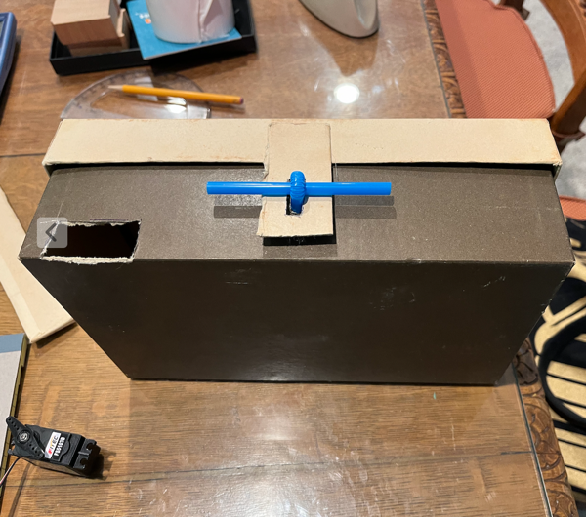

Figure 7 Shoebox treasure chest with cutout for servo.

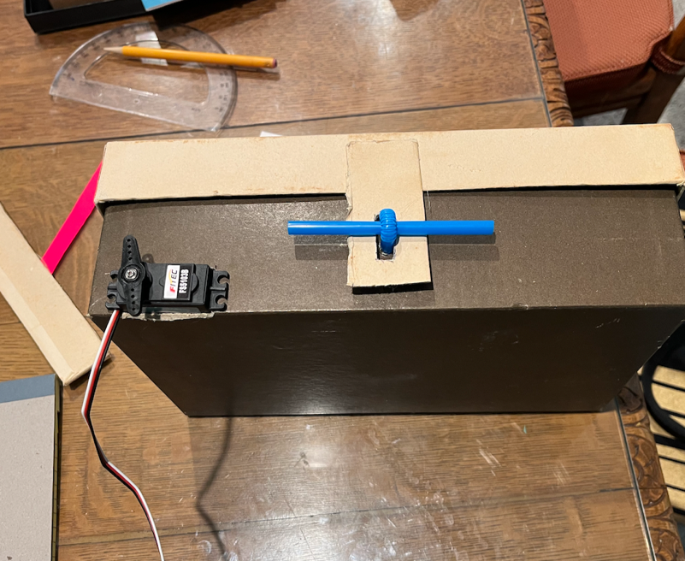

Figure 8 Shoebox treasure chest with servo inserted into cutout.

Design and test the mechanical connection between the servo and latch.

Your connection must allow the servo’s rotational motion to move the latch smoothly enough to release and secure the lid.

Evidence:
- labeled sketch or photo of the servo-to-latch connection
- photo of the initial mechanism
- screenshot of code that moves the latch
- brief note describing any binding, slipping, or alignment issue you observed

Extension: Try a second connection method and compare reliability.

KSB 4: Micro:bit Buttons
The micro:bit has two buttons on it, A and B (see Figure 9). These can be used as inputs to the Hummingbird controller.

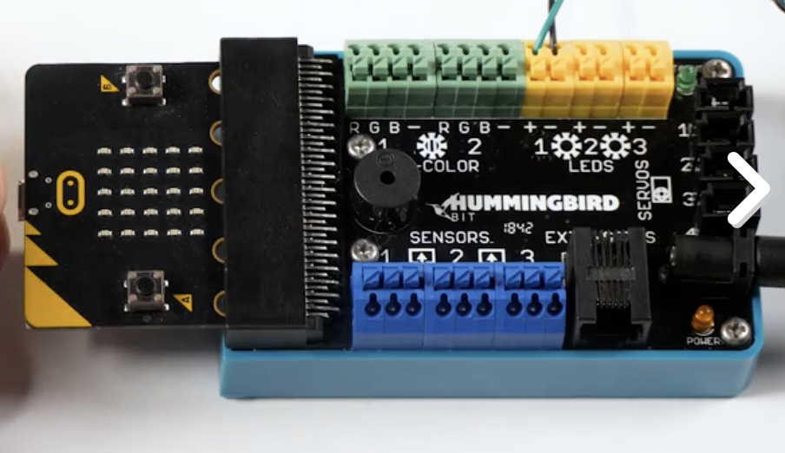

Figure 9 The A and B buttons are located on the micro:bit

Figure 10 illustrates an example of Snap! code that uses the Micro:bit Button A to turn on an LED.
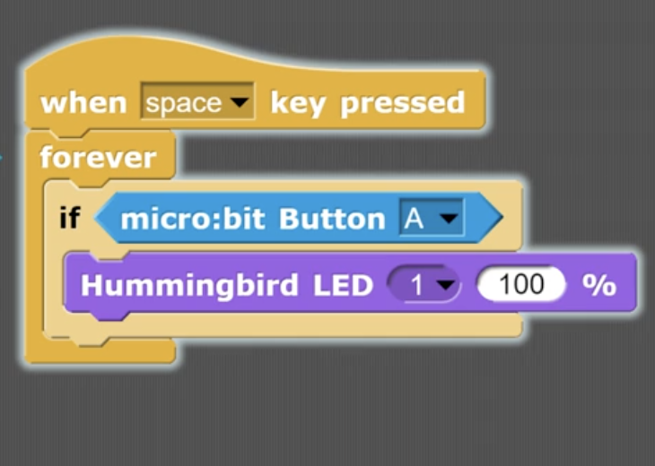

Figure 10 Code using micro:bit Button A to light an LED

Use the micro:bit A and B buttons as digital inputs.

Create a simple program that detects Button A and Button B separately so you know both inputs are working before building the lock sequence.

Evidence:
- screenshot of code that detects both buttons
- short note describing how the program responds to each input

Extension: Use a light or sound output to give feedback when a button press is recognized.

KSB 5: Micro:bit Code for Digital Input

You can program the A and B buttons on the micro:bit to act as a code, for example, ABA. When the person wanting to open the Treasure Chest presses this sequence, the dowel will rotate and the box can be opened. Here are the programming elements you will need to use (see Figure 11).
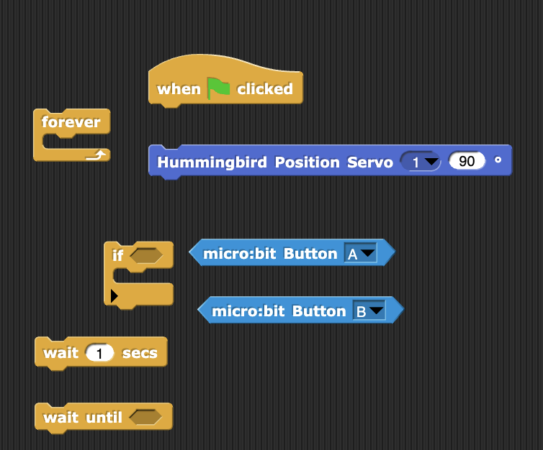

Figure 11. Programming Elements for Treasure Chest Code

Since you’ve experimented with the servo, you already know where you want the arm to be. When the green flag is clicked, the servo should move to the position where the dowel is in the hasp, and the Treasure Chest is locked. When creating a code, the more complicated it is, the harder it is to hack. For instance, a simple two-button code like AB has only four possible combinations (AB, BA, AA, BB). The number of possible combinations is 2 raised to the power of combination. With two buttons and two presses, there are 2² or four combinations. If you make the code ABA, the number of different possible combinations would 2³ or eight possibilities.

Let’s say you want the code to be ABA. So Micro:bit button A is pushed, then B is pushed, than A is pushed again, and the servo rotates opening the Treasure Chest. After the first two inputs AB, there needs to be a slight time delay for the next input to be registered.

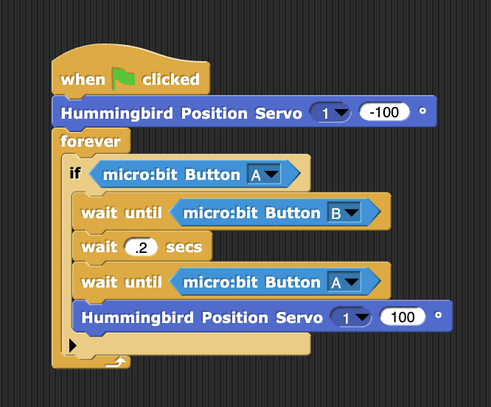

Figure 12 Code for ABA causes Servo to activate, rotate and open Treasure Chest.

Build a digital input sequence using Buttons A and B.

Plan the sequence before coding. Use at least four button inputs for the final lock so the code is more than a simple two- or three-press sequence.

Your program should:
- begin in the locked position
- recognize button presses in order
- unlock only after the correct sequence
- activate the planned surprise
- allow the chest to be locked again

Evidence:
- pseudocode or sequence plan
- screenshot of working lock code
- short explanation of how the program recognizes the correct sequence.

Alternative Treasure Chest Designs

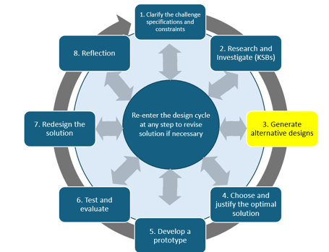
Make a few sketches and include brief explanations of how several different designs would work. How do you want the latch to open? What do you want the surprise to be? How complex do you want the code to be?

Create at least 3 meaningfully different Treasure Chest designs.

Each design should show:
- latch concept
- servo location/connection
- hinge/hasp arrangement
- planned digital code approach
- surprise feature
- approximate size or component layout

Evidence: Submit 3 labeled sketches with brief explanations.

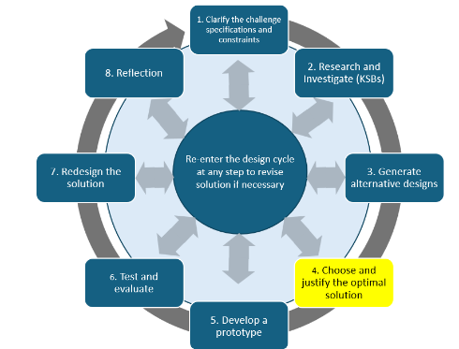
Optimal Treasure Chest—Part 1—The Structure

Which alternative design did you like best? This is the optimal design.

Review your 3 designs.

You may select one design or combine the strongest features from multiple ideas to create your best design.

Evidence:
- final labeled design sketch
- approximate dimensions
- latch and servo arrangement
- short explanation using at least two reasons such as reliability, smooth movement, security, simplicity, or use of materials.

Optimal Treasure Chest—Part 2—The Code
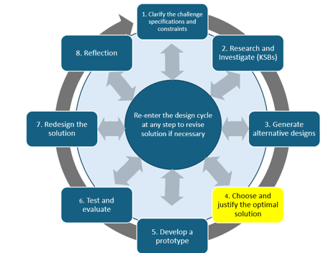
Now you need to put everything together and create a code, that when entered, will rotate the servo and open the Treasure Chest. Often, as you write and test code, you need to make changes. .
Use your planned sequence to create the complete digital-lock program.

Before coding, write short pseudocode that shows:
- start locked
- read button inputs
- check the sequence
- unlock if correct
- trigger the surprise
- return to a locked state

Evidence:
- pseudocode
- screenshot of initial code
- screenshot of final code
- short explanation of one meaningful code change.

Develop Your Prototype
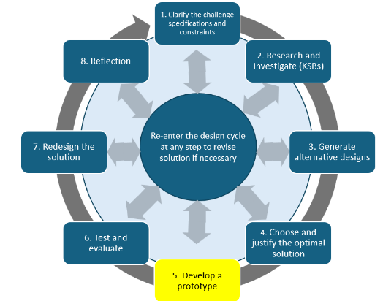
Now it is time to build your complete Treasure Chest, including the code, the servo, and the locking mechanism.
Build the complete Treasure Chest using the final design as your starting plan.

You may change latch geometry, servo position, connection materials, or chest structure if testing shows another approach works better.

Evidence:
- photo of the closed/locked chest
- photo showing the latch and servo mechanism
- screenshot of final code
- brief note describing any major build change and why it was made.

Test and Evaluate
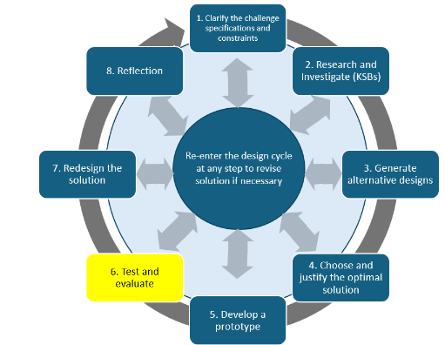
Did your solution work as intended and meet the design specifications?

Test the complete lock repeatedly.

Minimum requirement: 5 complete lock/unlock trials.

For each trial record:
- whether the correct code unlocked the chest
- whether the latch moved completely
- whether the chest could be relocked
- whether the surprise activated
- any failure or change made

Evidence: Submit a test table and short summary explaining reliability and whether the specifications were met.

Reflection
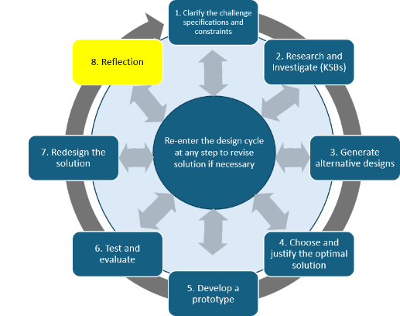
What did you learn?

Each team member completes an individual reflection.

Respond to:

What did you learn about converting servo rotation into latch movement?

What was the biggest challenge and how did you respond?

What did you contribute to the team?

What changed from the first design/code to the final version?

How did the surprise feature work?

If you had more time, what would you improve next?

Evidence: Submit your own reflection.

Self-Assessment: relative to design and engineering

Criteria | 1 – Beginning | 2 – Developing | 3 – Proficient
Alternative Designs | One design idea with limited detail. | Two designs are shown and compared. | At least three meaningfully different designs are shown; final design is selected or synthesized using at least two reasons.
Digital Lock Code | Code is incomplete or uses a short sequence with limited logic. | A four-or-more input sequence reliably unlocks the chest. | A four-or-more input sequence reliably unlocks, triggers the surprise, and supports returning to the locked state; logic is clearly explained.
Digital Lock Latch | Latch requires manual help or is unreliable. | Servo opens the latch automatically with some consistency. | Servo mechanism reliably locks and unlocks the chest; mechanical connection is documented and explained.
Final Design | Basic photo/code evidence is provided. | Final chest, mechanism, and code are documented with a short explanation. | Final chest, latch mechanism, initial/final code, and meaningful changes are documented with clear explanation.
Test and Evaluation | Limited testing with little evidence. | Several complete lock/unlock trials are completed and summarized. | At least 5 trials are recorded; lock, unlock, relock, and surprise performance are analyzed and changes are explained.
Reflection | Reflection is general or incomplete. | Individual reflection explains specific learning and contribution. | Individual reflection uses project examples to explain mechanism learning, challenge, contribution, iteration, surprise feature, and next improvement.

TOTAL ___________.

