MEDIA-2 Online Media Script Template Example - Online Media Script for Module 1: The Cutting Edge
DOMAIN: Materials and Manufacturing Technology (MMT)
MODULE TITLE: On the Cutting Edge: Developing a metal alloy to be used in the manufacture of surgical scalpels
MEDIA FORMAT: Simulation
KEY IDEAS:
- The term “processing” means transforming basic (raw) materials into industrial materials, and then into finished products.
- One way of processing materials is to affect the atomic structure of a material. The change is called structure change.
- Controlling the heating and cooling temperatures and rates determines the atomic structure of a material.
- Three processes that affect the material’s structure are hardening, tempering, and annealing.
- Hardening steel requires heating it to a high temperature and then cooling it rapidly. Through hardening, a material’s surface or internal structure is made physically harder.
- Tempering can preserve the material’s toughness and reduce the brittleness. Tempering involves heating hardened steel to a temperature of between 420° to 650° F (216° to 343° C) and soaking it at that temperature for a short time.
BRIEF SCENARIO: Students will be faced with the challenge of developing a carbon steel alloy to be used to make scalpels. They will learn about carbon allows, and heat treatment processes, and then select and test various alloy grades, and various heat treatment temperatures, as they move towards the final selection of the alloy they will specify. The final selection will then be “tested” in the simulation and they will be informed if their alloy was “accepted” by the surgeons.
DESCRIPTION OF THE ANIMATION/SIMULATION/ASSESSMENT: An engineering challenge based simulation, with a number of opportunities for animations to be included as the students get to learn more about steel and hw its properties are changed by the use of heat treatment. Since there are a number of stages/phases, assessment points can be built in where student comprehension of concepts can be tested by use of standard selected response question/responses. The major simulation element, whereby students will be able to select the range of carbon added to the alloy, plus the level of tempering applied, offer opportunities for the student to become involved in an optimization challenge. Once again, this offers some selected response opportunities, but also the student might be asked to provide some constructed response answers to better determine the level of understanding.
LEARNER BEHAVIOR: Interaction with the animations and sims as described.
ASSESSMENT EVIDENCE GATHERING METHOD(S) AND QUESTIONS: a variety of selected response types (exact type and frequency to be determined later. Constructed response might be used at the conclusion of the activity.

Screen Tab Title: Introduction
On Screen Text: | Text in Graphics/Animations: | Visual support: | Interactivity:
In hospitals throughout the world, surgeons perform life saving operations every day.  They have access to a wide range of specialist tools and equipment when they are in the operating theater. However, one of the most important tools they have is the humble scalpel. Without this vital piece of equipment, they would not be able to undertake a lot of the vital procedures needed to do their work.  [NEXT]  [NOTES: the opening page can be more dynamic, and if it is possible to find more images that can be used in the available landscape, then use them!] |  | 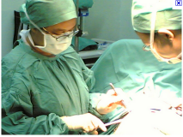 | None
The surgeon uses the scalpel in a variety of ways in the operating theater. The following describe the more common applications:  • Incision: The separation of biological tissues - surgical cutting  • Ablation: The removal of tissue - excision of tumors  • Cosmetic Application: Scar removal: wrinkle removal: skin rejuvenation  [NEXT] |  | 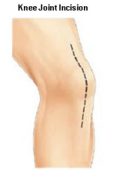

Learning Outcome Assessment

How are you proposing that we measure student success: None
<End of Page/Screen/Sequence>

Screen Tab Title: Your Challenge …
On Screen Text: | Text in Graphics/Animations: | Visual support: | Interactivity:
In this [design?] challenge, you are an engineer working in a medical research lab. Your task is to research the most suitable steel alloys that can be used to make scalpels in developing countries. In such countries, they do not have a lot of resources or finance, so you will be looking at the use of simple alloys of carbon steel to make the scalpel blades.  In the next section, you will learn more about carbon steel.  [NEXT]  [NOTES: we could add other images if it helps … not sure a blast furnace would be needed! ] | [We might want to be able to zoom in on a scalpel and look at the detail … not sure if we have the cursor change to a magnifying glass as it passes over the image, or if we have a click to zoom …  Once zoomed, the may want to identify the parts of the scaple. Let me know what you think and I’ll amend this accordingly] | 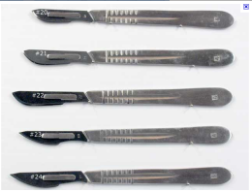 | None
Learning Outcome Assessment

How are you proposing that we measure student success: None

<End of Page/Screen/Sequence>

Screen Tab Title: Let’s do some Research!
On Screen Text: | Text in Graphics/Animations: | Visual support: | Interactivity:
The scalpel usually comprises a blade and a handle. We are only concerned with the blade in this research project.  The blade of a modern scalpel is usually made from an alloy of steel. In advanced counties with modern manufacturing facilities, a stainless steel alloy containing carbon and other elements such as chromium is often used since it does not corrode as easily as plain carbon steel. | [We might want to consider a brief animation of two blades – one SS, one CS, over time] | 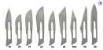
Let’s start looking at steel?  Do you know what it is made from?  [Click to Learn More] | [ON CLICK:  It is an alloy made from Iron (chemical symbol Fe) and Carbon (chemical symbol (C). The amount of carbon used is quite small (between 0.1 to 1.2%), however it does change the properties of the iron greatly, as you will see! | [pie chart of carbon steel needed … I’ll create in Excel if I can’t find one]

Screen Tab Title: What’s Inside a Sample of Steel
On Screen Text: | Text in Graphics/Animations: | Visual support: | Interactivity:
Did you know that metal contains crystals? It isn’t obvious when you look at everyday objects made from metal, but when you look very closely with a microscope, you can see crystals.  [Click to Learn More] | [ON CLICK:  Metal alloys comprise atoms of different elements combined in a regular pattern, known as a crystalline structure.  With your mouse, you can explore the crystal structure … click on the image and rotate, and zoom in an out!  [CLICK TO ROTATE: rotate left on left movement, right on right movement, etc. In and out on wheel movement ala Google Earth]  [NOTE: we may want to use carbon steel for this image … just couldn’t find anything as good as this image in a quick search] | 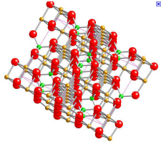
Carbon steel is a really special alloy. It is one of the very few alloys that when heated, it changes its crystalline structure.  It is this very unique feature of carbon steel that makes it possible to change how it behaves when subjected to forces.  Let’s explore what happens when we heat and cool carbon steel …  Click on the image left to start the heating process …  [NOTES: once the student has explored the heating phase … the next section should open as an extension of this element … [see below] | [NOTES:  STAGE 1  We need to be able to animate heating a sample of carbon steel – with some way of showing the crystalline structure at the same time. We might let the student be able to control the temperature by use of a slider that moves from 0 deg F to 1400 deg F. The specimen needs to start changing color from dull metal gray to dark red at around 1000 deg F changing to bright red dark orange at 1400 deg F. The crystal form will change from the left figure to the right figure at 1300 deg F. The change is gradual, so if we have a number of molecules, some will change before others, and as the temp. rises, they all then change. We want to encourage them to use the slider to raise and lower the temperature, and so see the structure changes. This will need some on screen text I’m sure, just not sure what until you have an idea of how we might do this!]  This chart gives some color/temp refs:  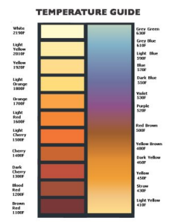 | 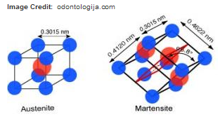
Now you have looked at heating, lets have a look at what happens to carbon steel if it is rapidly cooled from a very high temperature … | [NOTES: We can re use the above animation, but we need to add to it a QUENCH button so that the student can rapidly cool the sample from about 1400 deg F, and in doing so “lock” the crystal structure as Martensitic (right hand image). We need to also allow them to see the “before” and “after” quenching crystal structure so they can see the difference.  We do want to allow then to quench from below 1400 deg F and for the structure to look like Austenitic (left hand image).
Learning Outcome Assessment
How are you proposing that we measure student success: This might be a good point to use some selected response questions )perhaps a few multiple choice and a matching question. The MECH TEAM should be able to provide the Q&As.

<End of Page/Screen/Sequence>

Screen Tab Title: Let’s look at Heat Treatment
On Screen Text: | Text in Graphics/Animations: | Visual support: | Interactivity:
When carbon steel is heated to above 1400ºF (red hot), and quenched (cooled) rapidly, the carbon atoms are trapped in a face centered cubic crystalline formation. This state is also known as a Martensitic formation. Steel is very hard when in this state, but very brittle too.  The hardness increases with the quantity of carbon in the alloy.  As well as being very hard, such carbon steel is very brittle (it breaks easily when subjected to a force and is not very tough).  This operation is known as HARDENING | [this might be animated so the student could slide the % of C and see the Hardness figure increase. Is there a way that we could use a Vickers testing machine and vary the % to then see the results – see panle below for a diagram of a Vcikers test and machine] | Hardness (Vickers Test)  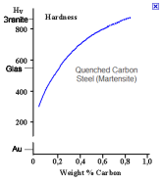
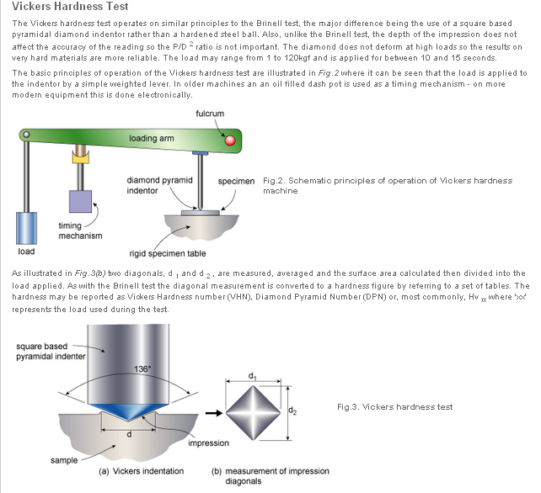
 | [it would be a much more interesting if we could use an animation of an Izod tester, with the student able to select the C range as per above, and then see the breakage reading  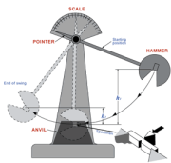 | 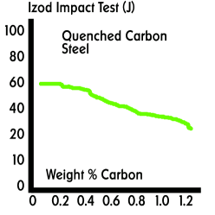
If carbon steel is heated to above 1400ºF (red hot), and then allowed to cool very slowly, the carbon atoms return to a body centered cubic crystalline formation. This state is also known as a Austenic formation.  Carbon steel is much softer in this state, although the hardness does increase somewhat with the quantity of carbon in the iron.  As well as being a lot softer, carbon steel is a lot less brittle (tougher) and can withstand much higher forces before breaking or bending.  This operation is known as ANNEALING. | [ditto] | 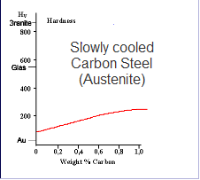  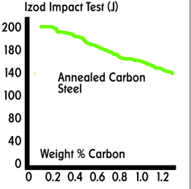
Carbon steel can be very hard and brittle in its HARDENED state, and much less hard and less brittle in its ANNEALED state.  It is possible to use another heat treatment process to adjust the physical properties of steel between these two extremes.  This process is known as TEMPERING.  Let’s look at a sample of medium carbon steel (0.8% carbon) being tempered at a number of different temperatures. You will have an opportunity to see if it makes a difference to the hardness and the impact resistance (toughness) of the sample! | [NOTES: It would be helpful if we could animate an oven being used, whereby a sample of steel (grayish in color enters the kiln, it glows red the temperature rises to, say, a temperature selected from a range of 7 (300-900degF), and the sample is removed and quenched in a bath of water … lots of steam and hissing.  A GRAPH button appears, and when clicked, the student sees the hardness/impact test results as per the graph below.  They only see the points on the graph for the temp they chose. They repeat to get the other points on the graph until they have the full graph. | [STAGE1]  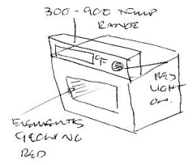  [THEN A BATH OF WATER … HISSING AND STEAM!]  [STAGE 2  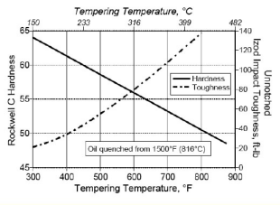  (from http://www.navaching.com/forge/heattreat.html)
Learning Outcome Assessment
How are you proposing that we measure student success: constructed response questions needed from writing team
<End of Page/Screen/Sequence>

